

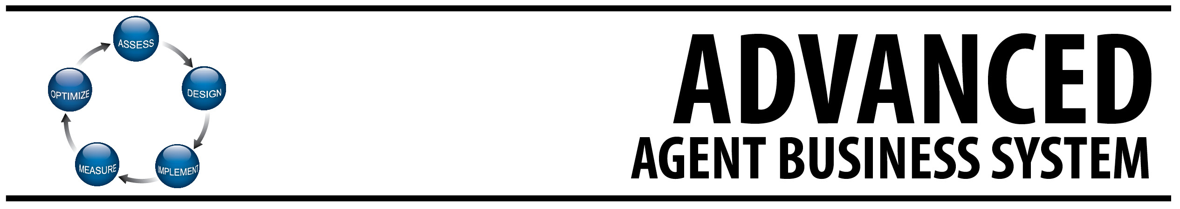

The PGR Advanced Agent Business System will help you assess your past results and design a winning strategy & plan for 2013. Then you can implement your plan, measure the results and optimize each quarter.

STEP ONE – ASSESS YOUR PERFORMANCE:

Last Year’s Numbers:

Income:
Total Transactions (including leases): ____________________
Listing Appointments: ____________________
Listings Taken: ____________________
Listings Sold: ____________________
Buyer Appointments: ____________________
Buyer Offers Written: ____________________
Buyer Sales: ____________________
TeamBuilder Income: ____________________
Current Active Listings: ____________________
Current Pendings: ____________________

% of Listing Appointments to Listings Taken: ___________%
% of Listings Taken to Listings Sold: ___________%
% of Buyer Appointments to Buyer Offers: ___________%
% of Buyer Contracts Written to Buyer Closings: ___________%
% of Listings vs. Buyer Sales: L: ________% B: __________%

Sources of Closed Transactions and Income

(Insert the number of transactions, dollar volume and GCI amounts in each category)
 | Buyers | Sellers | Investors | Renters/  Prop. Mgmt | Referrals | Team  Builder
Number
Transactions
$ Volume
GCI
Lead Generation Sources

(Insert the number for the sources of your closed transactions.)

 | Buyers | Sellers | Investors | Renters/  Prop. Mgmt | Referrals | Team  Builder
Past
Clients
Personal Network
Geographic Farming
Online Marketing
Social Networking
Business Networks
Expired Listings
FSBO
Open House
Company Lead

Current Market Analysis

- What Are Your Current Market(s)?

Target Market | Estimated Number of 2013 Transactions

- How Big Are Your Markets? – You can look at past results in FMLS or MLS to determine how many transactions were done in your geographic areas. If you only work your sphere, look at past performance. A common scenario is for agents to realize that their sphere is not sufficient to meet their goals.

- What Are The Changing Trends?

Target Market | Changing Trends for 2013

- Do You Need To Change For 2013? Does your current market(s) support your desired income for 2013?

Competitive Analysis – You
(What Were You Known For In 2012?)
Strengths | Weaknesses
Opportunities | Competitive Threats

Competitive Analysis – Competitor 1
Strengths | Weaknesses
Opportunities | Competitive Threats
Competitive Analysis – Competitor 2
Strengths | Weaknesses
Opportunities | Competitive Threats

Did You Have A Prospecting Database in 2012?

One of the most common gaps for real estate agents is not having a database that allows you to stay in touch with potential clients. Remember, the most common reason clients do not use the same agent again is they do not remember their name or do not have their contact information. If you need help creating your database, please contact your broker or agent marketing services.

Level 1 Database Marketing:
Establish Database, Send Something!

Advanced Level Database Marketing:
Customize Database With Targeted Groups
Create Custom Content For Specific Groups
Create “Calls To Action” To Contact You/ Get Something
Implement An Integrated Marketing Plan Using Different Mediums
(eCampaigns, Direct Mail, Social Media, Website, Phone Calls, Local Print Ads)
Review 2012 Strategy & Plans
Think back to the beginning of 2012. If you could have a “do over” what would be different for 2012?
Work smarter in 2013!

What Worked In 2012
2.
3.
4.
5.

What Did Not Work In 2012
1.
2.
3.
4.
5.

What Would You Do Differently?
1.
2.
3.
4.
5.
STEP TWO – DESIGN YOUR PLAN:

2013 Goals and Objectives:

Business Goals, Personal Goals & Aspirations

2013 Financial Goal

Financial Goal (total income required to earn) $_____________________

My average commission per transaction: $_____________________

# of transaction sides necessary to achieve goal: _____________________

Required buyer sales for the year: _____________________

Required listings sold for the year: _____________________

TeamBuilder/ Referral Income: $____________________

In order to have _________ listings sold, I must obtain_________ listings annually and go on ________ listing appointments annually (or ______ a month- divide # by 12)

In order to have _________ buyer sales, I must write _________ buyer offers annually and go on _______ buyer appointments annually (or _______ a month- divide # by 12)

_______________ Total Income To Be Earned in 2013
_______________ Total Business Expenses
_______________ Total Net Profit

2013 Business Generating Activities:

Examples: enhance my prospect database, participate in SCORE, participate in 2013 PGRPerformers, OwnAmerica, host a client party, referrals from volunteer projects, farming, conduct open houses, work FSBO’s, enhance online marketing, get started on Facebook, present market trends at a HOA meeting, target expired listings, invite co-op agents to events, create custom market reports or newsletter, etc.

Major Activities To Generate Buyers
1.
2.
3.
4.
5.

Major Activities To Generate Listings
1.
2.
3.
4.
5.

Major Activities To Generate Investors
1.
2.
3.

Major Activities To Generate Renters/ Property Management
1.
2.
3.

Major Activities To Generate Referrals/ TeamBuilder
1.
2.
3.

2013 Target Markets:



- Are Your Target Markets Big Enough To Reach Your Goals?
- Is It Realistic To Win In 2013?
- What Might Be Your Unique Value Proposition?
- Should You Begin To Invest In Some Target Markets For 2014And Beyond?

Target Markets | Specializations
Community/ Neighborhood  City  Zip Code  Area Of Town (Buckhead)  County  Personal Sphere  Referrals | Fine Homes  New Homes  Bank-Owned/ REO  Short Sales  Investors  Lake/ Mountain  Relocation  Intown Condos  Commercial | Multi-Generational  Multi-Cultural/ Int.  Diversity  Land/ Lots  Eco-Friendly  Equestrian  Resorts/ 2nd Homes  Lease/ Rentals

2013 Target Markets | Estimated Sales Volumes

2013 Database Marketing Plan

Make a commitment to optimize your database marketing plan for 2013! This will make you money. PGR agents have a variety of options for both content and mediums that might be interesting and valuable for your prospects. Here are some examples you may consider

Content | Mediums
- Local Market Reports (RealValuator, Other)  - Home Values (Case-Shiller, Other)  - Foreclosure Data (RealValuator, RealtyTrac)  - Short Sale ASAP  - Job Loss Protection  - Mortgage Rate Trends  - Cost of Waiting for Baby Boomers  - Relocation Trends  - Population/ Employment Trends  - Local News & Insight  - Client Success Stories  - Investors (Own America)  - Property Management  - Mobile Trends | - PGR Real Estate Advisor (Agent Website)  - My Home Finder/ ListingBook (FMLS)  - Craigslist (HTML posts from agent website)  - RISMedia E-Newsletters (Daily, Monthly)  - PREA CFL, PREA E-Cards, Postcards  - AnnounceMyMove, AnnounceMyListing  - ATLScoop.com, AtlantaRealEstateChannel.com  - PGR Webinars  - Blogs, Audio Podcasts, Video Reports  - Postcards, Custom Marketing Solutions  - Targeted Print Ads  - Social Media (Facebook, Twitter)  - Mobile (Text, Groups/ Beluga)

Here Is An Example:

Date | Target Market | Value Message | Medium | Cost
Jan | Community A | Adv. Property Marketing For Spring | AMM | $0
Jan | Community B | Spring Market Will See  Improving Homes Values | Community Newsletter | $200
Jan | Past Clients | Thanks/ Appreciate Referrals | Jumbo Postcards w/ Personal Note | $300
Jan | General Prospects | Market News | PGR Website Newsletter | $0
Feb | Community A | Market Update /Short Sale Info | Email List | $0
Feb | Community B | Best Practices / APMS | Community Newsletter | $200
Feb | Past Clients | Market Update | Email | $0
Feb | General Prospects | Real Estate News & Information | RISMedia | $0

Complete Your 2013 Database Marketing Plan
Date | Target Market | Value Message | Medium | Cost
2013 Online Marketing & Social Media Plan

 | Yes/No | Notes
Agent Websites:
Do you have good graphics/ photo/ layout?
- Do you have custom domain name? Is it easy to remember and easy to spell?
Is your contact info current & easy to find?
Do you have compelling “Calls to Action” to get your visitors to contact you – turn clicks into leads?
Do you have custom, valuable content that your visitors will come back for & recommend your site to others?
Do you use multimedia, including videos and social network connections?
Do you have regular, relevant updates such as market reports or a blog?
SEO: do you have one or more targeted markets that your site is designed to get your site found in Google searches?
Is your site error-free? no broken links or outdated content
Listing Enhancements:
Do you understand how VHT works and the value for your clients?
Have you uploaded high resolution photos to My VHT for the full HD screen slideshow?
Is your Realtor.com profile current and professionally representative?
Do your listings have narrated videos, where appropriate?
Are you “telling the story” of the property with the right verbiage, photos, incentives & media?
Is your property enhanced on Realtor.com and PGR intranet (expanded text, headlines, photos)?
Do you understand how listing syndication works and how your properties are found on websites like Trulia & Zillow?
Social Media:
Is your LinkedIn profile current and do you have recommendations from past clients & colleagues?
Is your Facebook page setup correctly with the right blend of personal and professional info?
Do you engage with your FB Friends socially rather than just real estate related?
Do you post from time to time about real estate in a way that your FB Friends find valuable?

2013 Sales Pipeline Management
One of the keys to real estate sales is your sales pipeline. Top agents track and manage their sales pipeline to ensure they know their progress every month and have the best chance to attain their goals.

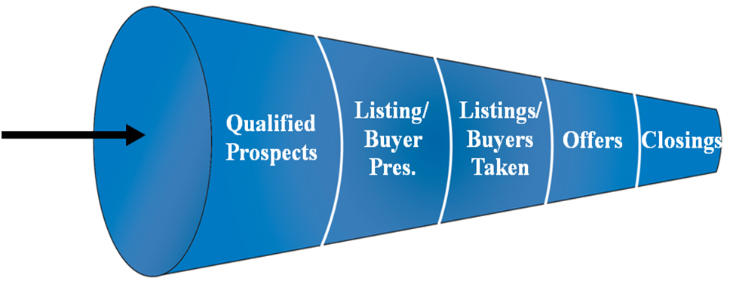
Suspects

PGR Has Made This Simpler By Implementing Our SCORE Campaigns As A Part Of Game Plan 2013. Here is an example of a sales pipeline worksheet. We also have an Excel spreadsheet version on the PGR Agent Intranet under the Game Plan section.

 | Suspects | Qualified Prospects | Proposals | Listings/ Buyers Taken | Offers | Closings
Numbers | 850 | 170 | 34 | 17 | 10 | 8
Ratios | 20% | 20% | 50% | 60% | 80%
GCI $ | $5.2 Mil | $1.04 Mil | $208,334 | $104,167 | $62,500 | $50,000
Total Sales | $208 Mil | $41.6 Mil | $8.32 Mil | $4.16 Mil | $2.5 Mil | $2 Mil

Please complete your sales pipeline worksheet for 2013.

 | Suspects | Qualified Prospects | Proposals | Listings/ Buyers Taken | Offers | Closings
Numbers
Ratios
GCI $
Total Sales

Lead Incubation & Management: Do you have a system to incubate potential leads and manage them so you have no missed opportunities? Please describe that process or what you intend to do differently in 2013.

____________________________________________________________________________________________________________________________________________________________________________________________________________________________________________________________________________________________________________________________________________________________________



I will make the commitment to participate in SCORE for 2013! Initials: _________

2013 Coaching, Training or Agent Services
Should you sign up for PGRPerformers? Do you need to improve your Advanced Property Marketing System skills or customize your listing presentation? Do you understand how to use our tools for market trends and property research? Do you know how our alliance partners can help you be more successful? Do you know how to leverage our online marketing solutions? Do you know how to leverage our mobile solutions? Is your prospect database set up and segmented? Do you need to get Agent Marketing Services to do some things for you – so you can focus on selling? Should you get a new designation? Focus on the things that make you more valuable to your clients!

I will make the commitment to participate in PGRPerformers! Initials: _________

Training/ Coaching or Experience | Date

2013 Systems, Resources and Processes

The best use of your time is to stay focused on generating leads, servicing your clients and networking. Top agents leverage systems, resources and streamlined processes so they can prioritize their time in the best places. Please identify the areas that you need to address in 2013 so you can work smarter.

Current Gaps or Opportunities | Solution | Completion Date

How can the broker, office staff, our corporate teams and our alliance partners assist you in achieving the results you desire in the upcoming year?

____________________________________________________________________________________________________________________________________________________________________________________________________________________________________________________________________________________________________________________________________________________________________
2013 Mindset, Wellness & Time Management

Top agents manage their mindset to maintain a winning attitude. They avoid “energy-sucking vampires” and prioritize their activities every day. Top agents also make the time to keep their bodies healthy – because it impacts your business. Please identify the areas that you need to address in 2013.

Current Gaps Or Opportunities | Solution | Completion Date

Prioritize Your Time For
Selling, Networking and Selling!

Time | Most Valuable Daily Activities

2012 Wealth Building Plan

Top agents have a plan for their future health, wealth and retirement. Please identify your gaps and opportunities. The PGR DreamBuilder team is ready to assist you for your planning.

Current/ Gaps | Solution | Completion Date
Tax Planning
Medical Coverage
Disability
(Short-Term & Long-Term)
401K/ Retirement Plan
Real Estate Investments
Long-Term Care



STEP THREE- IMPLEMENT YOUR PLAN:

These are the key things that need to happen to implement my 2013 plan. Also identify the things that may prevent you from implementing your plan.

Keys To Implementation | Roadblocks

STEP FOUR – MEASURE YOUR PERFORMANCE:

These are the key areas I plan to measure my performance for 2013 that will have an impact on my business.

Area of Performance | Measurement

STEP FIVE – OPTIMIZE YOUR PLAN:

These are the dates that I plan to review my performance and optimize my business plan to achieve my goals in 2013. I have them scheduled on my calendar.

Designated Review | Planned Date of Review
End of 1st Quarter Review
End of 2nd Quarter Review
End of 3rd Quarter Review
End of 4th Quarter Review

I am committed to the activities necessary to achieve my desired results in 2013!

Sales Professional Name: __________________________________________________

Signature: _________________________________________ Date: ______________

Broker/ Coach: _____________________________________ Date: ______________




Disciplined People! Disciplined Thought! Disciplined Action!
Choose To Be A Shark – Not A Goldfish!
2013 Can Be The Best Year Of Your Career...
Make The Choice To Work Smarter!

