**Metro Atlanta Case-Shiller Index Reported February 2013**

The latest Case-Shiller Index was published on Tuesday, February 26th 2013. As always, the index reports on data 60 days in arrears. Therefore, the index reports Metro Atlanta home values for December 2012. Things are improving in our market however two important considerations must be taken into account. First, the Case-Shiller Index of home values is very different from average sale prices or median homes prices. The Case-Shiller Index reports on repeat properties sold, which are generally better indicators of home values. Second, this index reflects average home values for all of Metro Atlanta. Remember, real estate is local and every market is different. There are some local communities that have held their values reasonably well and others that may continue to decline. In fact, some homes entering the market are getting multiple offers and closed prices above list price. Your local Prudential Georgia Realty agent can help you understand the specific metrics in your local market.

Now for the news… Nationally average home prices increased by .02% when compared to last month and increased 7.3% over the past year. **The December index for Atlanta shows a .28% (non-seasonally adjusted) increase in home values from November 2012 and a 9.91% increase over the last year.** While these numbers are positive, we must bear in mind that home prices are still down 29.69% from the peak of July 2007. The current Case-Shiller index reflects values similar to the spring of 1999. The November index for Atlanta is 95.95. Atlanta and Detroit posted their largest year-over-year increases since the index started tracking results in 1991. New York, Chicago and Cleveland show the worst performance over the past year.

The Metro Atlanta real estate market continues to show signs of improvement for sellers. Listing inventory is down 37% from January of 2012 and down 57% from January of 2011. That represents around 4 months supply of inventory based upon the latest closed sales trend. Six months supply is considered normal. We have seen an extended period of low inventory since last year. Buyer activity remains strong led by baby boomers, first time buyers and investors. At the same time, the pace of pre-foreclosures (notices of default) and foreclosures has slowed. RealValuator reports that short sales and foreclosures were over 60% of the transactions sold in 2010, 47% in 2011 and 37% in 2012. Market sales (resales, new homes) are outpacing bank-owned sales. Your local PGR agent can show you the specific conditions in your market so you can make the best real estate decisions.

We have now seen a series of positive results from the Case-Shiller Index but the last few months show the trend leveling off for the winter months. We are moving back to a more normal seasonal pattern where the spring and summer months are the heaviest selling months. View the graph of the monthly Case-Shiller results from 2010, 2011 and 2012:

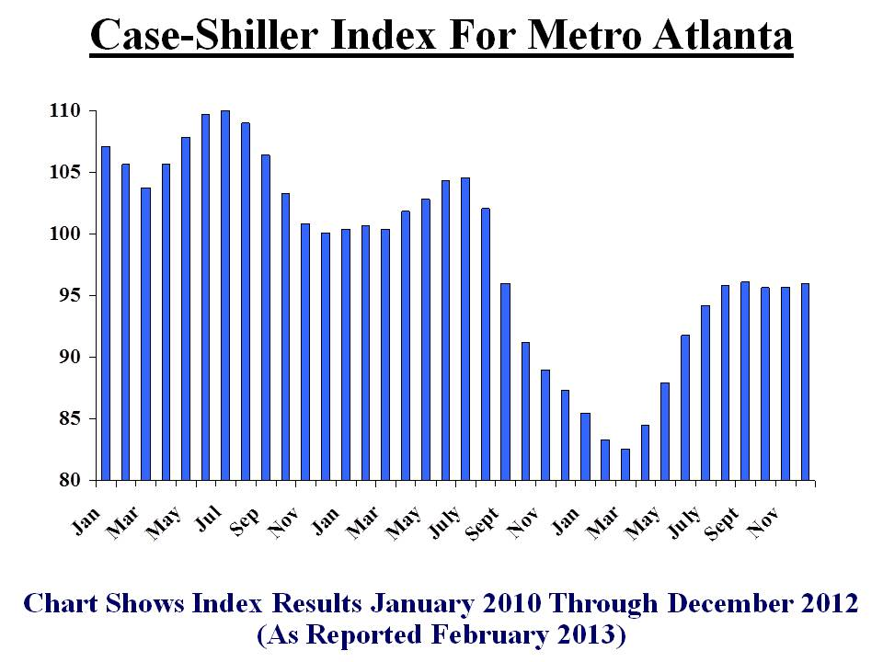

If you look back further at home values (see chart below), you can see that we had a bubble in homes values. As with many cyclical markets, we have over-corrected with values that are below the normal trend line. Over time, we expect this pattern to normalize and values will return to this predictable track. That makes now a great time to buy or invest in real estate for Metro Atlanta!

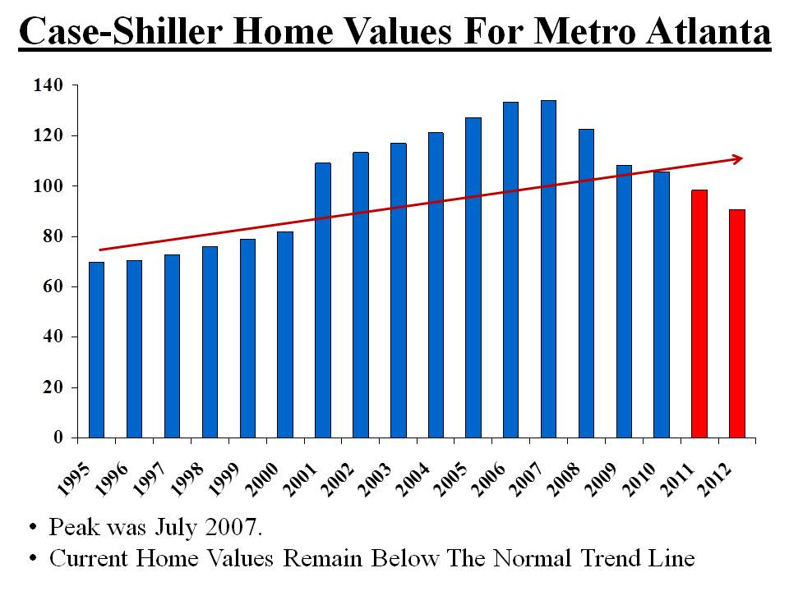

This chart shows the end of the year (December) index for recent years. As you can see, we had a steady decline for 5 years but are showing a positive trend compared to last year.

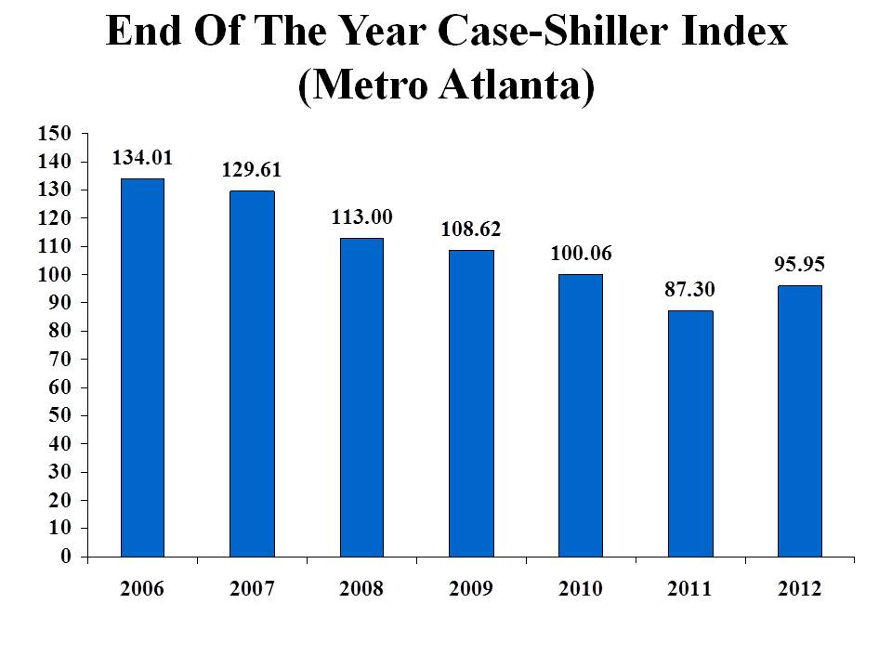

If you look at the average annual Case-Shiller index for each year, here is how homes purchased in recent years would compare to the current index:

Homes Bought in 2000 – Loss of 7.05%  
Homes Bought in 2001 – Loss of 11.98%  
Homes Bought in 2002 – Loss of 15.25%  
Homes Bought in 2003 – Loss of 17.92%  
Homes Bought in 2004 – Loss of 20.71%  
Homes Bought in 2005 – Loss of 24.52%  
Homes Bought in 2006 – Loss of 27.96%  
Homes Bought in 2007 – Loss of 28.42%  
Homes Bought in 2008 – Loss of 21.77%  
Homes Bought in 2009 – Loss of 11.49%  
Homes Bought in 2010 – Loss of 9.28%  
Homes Bought in 2011 – Loss of 2.45%

Yes, we are slowly climbing our way out of this unprecedented housing crisis – but we are not quite there yet. So where will home values go from here? The key factors that will impact our home values include the following:

**Demand from Buyers**: SmartNumbers reports that we finished 2012 with over 75,000 homes sold – a 7% increase from 2011. We are moving back toward a more normal expectation of 80,000 to 85,000 homes sold per year.

**Mortgage Rates/ Credit Availability:** Average mortgage rates in the past 50 years were 8%. We expect to see historically low mortgage rates continue now that the Fed is still purchasing $85 billion of bonds and mortgage-backed securities each month. But this stimulus to keep rates artificially low will not last forever as the Fed is already signaling they may start to slow down this program. Freddie Mac and the Mortgage Bankers Association predict mortgage rates to rise to over 4% in 2013. In 3-5 years, we expect to see rates in the 6-8% range again.

**Supply/ Inventory Levels**: Most of our markets are showing inventory levels down well over 30% from the prior year levels. We see investors very active under $200,000 which will continue to shrink that inventory. New homes will continue to grow but not fast enough to have a significant impact on inventory levels. As values begin to rise, we expect “sideline sellers” to get back into the market. Overall, the “for sale” inventory will remain low compared to normal levels.

**Competition from Short Sales/ Foreclosures:** In 201o, RealValuator reports that short sales and foreclosures were over 60% of the transactions sold. In 2011, that dropped to 47% and in 37% in 2012. We are now seeing resales and new homes outpace the sales of bank-owned properties.

It is clear that the housing market for the Greater Metro Atlanta area is improving. Right now, we still have low prices and incredible mortgage rates. You and your agent should be carefully watching the leading indicators. There are some great opportunities to buy or invest. But the low inventory may cause prices to start rising at an abnormally high rate. **In 5 or 10 years, many will look back and regret not buying their dream home when they had the chance!** Check back for our next posts with the latest facts and insight that can make you money!