**Case-Shiller Index For Metro Atlanta   
As Reported March 2013**

The latest Case-Shiller Index was published on Tuesday, March 26th 2013. As always, the index reports on data 60 days in arrears. Therefore, the index reports Metro Atlanta home values for January 2013. So what does the latest index show and what does that mean for home values in Metro Atlanta? Things are improving in our market however two important considerations must be taken into account. First, the Case-Shiller index of home values is very different from average sale prices or median homes prices. The Case-Shiller Index reports on repeat properties sold, which are generally better indicators of home values. Second, this index reflects average home values for all of Metro Atlanta. Remember, real estate is local and every market is different. There are some local communities that have held their values reasonably well and others that may continue to decline. In fact, some homes entering the market are getting multiple offers and closed prices above list price. Your local Prudential Georgia Realty agent can help you understand the specific metrics in your local market. However, the Case-Shiller Index is a good general indication on what is happening in our market.

Now for the news…. Nationally average home prices increased by .01% when compared to last month and increased 8.1% over the past year. **The January index for Atlanta shows a 1% (non-seasonally adjusted) increase in home values from December 2012 and a 13.41% increase over the last year.** While these numbers are positive, we must bear in mind that home prices are still down 29% from the peak of July 2007. The current Case-Shiller index reflects values similar to home values in the summer of 1999. The January index for Atlanta is 96.90. All 20 cities in the Case-Shiller Index showed positive year-over-year gains for Janaury. Detroit was the only city to show a deceleration and New York finally came into positive territory after 28 months of negative annual returns.

The Metro Atlanta real estate market continues to show signs of improvement for sellers. Listing inventory is down 38.7% from March of 2012 and down 57% from March of 2011. That represents around 3.4 months supply of inventory based upon the latest pending sales trend. Six months supply is considered normal. We have seen an extended period of low inventory since last year. Buyer activity remains strong led by baby boomers, first time buyers and investors. At the same time, the pace of pre-foreclosures (notices of default) and foreclosures has slowed. RealValuator reports that short sales and foreclosures were over 60% of the transactions sold in 2010 but are now down to 37% in 2013. Market sales (resales, new homes) are outpacing bank-owned sales. Your local PGR agent can show you the specific conditions in your market so you can make the best real estate decisions.

We have now seen a series of positive results from the Case-Shiller Index but the last few months show the trend slowing or leveling off. Over the next few months, we expect to see more positive results as we move toward the spring market. We are moving back to a more normal seasonal pattern where the spring and summer months are the heaviest selling months. View the graph of the monthly Case-Shiller results from 2010, 2011, 2012 and 2013:

[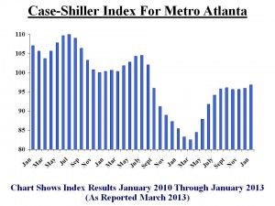](http://www.atlrealestatescoop.com/wp-content/uploads/2013/03/Slide1.jpg)

If you look back further at home values (see chart below), you can see that we had a bubble in homes values. As with many cyclical markets, we have over-corrected with values that are below the normal trend line. Over time, we expect this pattern to normalize and values will return to this predictable track. That makes now a great time to buy or invest in real estate for Metro Atlanta – BUT don’t wait too long!

[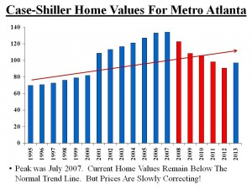](http://www.atlrealestatescoop.com/wp-content/uploads/2013/03/Slide2.jpg)

This chart shows the “months supply” based upon price ranges. As you can see, the supply is very low in the lower price ranges. Some of this is due to heavy investor activity under $200,000. As you get to the luxury market, there is more supply available based on the rate of sales. Contact your local PGR agent to see the latest trends in your specific area.

[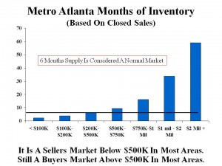](http://www.atlrealestatescoop.com/wp-content/uploads/2013/03/Supply-Trends-By-Price-March-2013.jpg)

If you look at the average annual Case-Shiller index for each year, here is how homes purchased in recent years would compare to the current index:

Homes Bought in 2000 – Loss of 7.05%  
Homes Bought in 2001 – Loss of 11.98%  
Homes Bought in 2002 – Loss of 15.25%  
Homes Bought in 2003 – Loss of 17.92%  
Homes Bought in 2004 – Loss of 20.71%  
Homes Bought in 2005 – Loss of 24.52%  
Homes Bought in 2006 – Loss of 27.96%  
Homes Bought in 2007 – Loss of 28.42%  
Homes Bought in 2008 – Loss of 21.77%  
Homes Bought in 2009 – Loss of 11.49%  
Homes Bought in 2010 – Loss of 9.28%  
Homes Bought in 2011 – Loss of 2.45%  
Homes Bought in 2012 – **Gain of 6.82%**

Yes, we are slowly climbing our way out of this unprecedented housing crisis – but we are not quite there yet. So where will home values go from here? The key factors that will impact our home values include the following:

**Demand from Buyers**: SmartNumbers reports that we finished 2012 with over 75,000 homes sold – a 7% increase from 2011. We expect to see an 8-10% increase in units for 2013. We are moving back toward a more normal expectation of 80,000 to 85,000 homes sold per year.

**Mortgage Rates/ Credit Availability:** Average mortgage rates in the past 50 years were 8%. We expect to see historically low mortgage rates continue while the Fed is still purchasing $85 billion of bonds and mortgage-backed securities each month. But this stimulus to keep rates artificially low will not last forever as the Fed is already signaling they may start to slow down this program. Freddie Mac and the Mortgage Bankers Association predict mortgage rates to rise to over 4% in 2013. In 3-5 years, we expect to see rates in the 6-8% range again.

**Supply/ Inventory Levels**: Most of our markets are showing inventory levels down well over 30% from the prior year levels. We see investors very active under $200,000 which will continue to shrink that inventory. New homes will continue to grow but not fast enough to have a significant impact on inventory levels. As values begin to rise, we expect “sideline sellers” to get back into the market. Overall, the “for sale” inventory will remain low compared to normal levels.

**Competition from Short Sales/ Foreclosures:** In 201o, RealValuator reports that short sales and foreclosures were over 60% of the transactions sold but have dropped to 37% in 2013. We are now seeing resales and new homes outpace the sales of bank-owned properties.

It is clear that the housing market for the Greater Metro Atlanta area is improving. Right now, we still have low prices and incredible mortgage rates. You and your agent should be carefully watching the leading indicators. There are some great opportunities to buy or invest. But the low inventory may cause prices to start rising at an abnormally high rate. **In 5 or 10 years, many will look back and regret not buying their dream home when they had the chance!** Check back for our next posts with the latest facts and insight that can make you money!