**Prudential Georgia Realty Real Estate Advisor  
August 2013**

We are providing this monthly real estate advisor report to keep you informed about the latest trends and issues in the real estate market. If you know someone else who might be interested in receiving this report or who may benefit from our expertise, please let us know. Better information helps our clients make better real estate decisions!

**Greater Metro Atlanta Real Estate Update**



* For the Greater Metro Atlanta area, listed inventory is up 18% from the lowest point in February 2013. But inventory remains down 19% compared to 2012 levels and down 48% from 2011. The limited availability of quality properties with reasonable value has turned many local areas into a seller’s market.
* The available “months of supply” is 3.8 months based upon closed sales (6 months is considered normal).
* There is a feeding frenzy for desirable properties where multiple offers are becoming the norm. Buyer demand is very strong and pendings are running ahead of last year. But actual closed transactions have been down every month this year when compared to 2012. That means the fallout rates are higher than normal.
* The pace of short sales and foreclosures coming on the market has slowed considerably. In 2010, over 60% of sales were distressed properties but that is now down to 37%. Resales are the larger mix of sales.
* New Homes are making a slow but sure comeback. New home closings are up 55% from last quarter. There are some wonderful new home communities coming online with the latest innovations in smart building that may be great options for buyers. [Click here to view new home communities.](http://www.prudentialganewhomes.com)
* The Case-Shiller Index reports that Metro Atlanta home values have increased 21% in the last 12 months. But values remain down 25% from the peak of July 2007. [Click here for the latest Case-Shiller report](http://www.atlrealestatescoop.com/category/case-shiller/).
* Home values will continue to rise in 2013 – especially in the lower price points driven by the very low levels of inventory and strong buyer demand.
* Appraisals can be a problem. In areas where prices are rising, the appraiser may not be considering the latest comps or may not be able to use some comps that were done as private transactions. We can help provide information to the appraiser in the right formats that give you the best chance to get the highest value.
* [Click Here](http://www.atlrealestatescoop.com/wp-content/uploads/2013/07/Market-Trends-July-2013.pdf) for a detailed set of slides that show the National Market, the Metro Atlanta Market, The New Homes Market and how our company is performing. There is a reason we are ranked #1 in Metro Atlanta.

**This is an unprecedented opportunity to buy the home of your dreams while prices and financing are historically low. But these conditions will not last as the real estate market continues to recover.**

**Mortgage Rates Rising – Time To Make Your Move!**

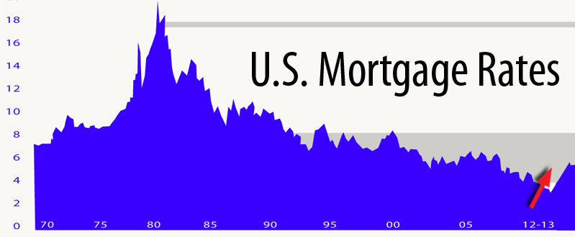

Mortgage rates are on the rise, but fell back slightly in recent weeks. Many buyers are realizing that the long-term trend is upward and home values are also rising. Now may be the time to make your move!

On July 23rd, Freddie Mac released the results of its Primary Mortgage Market Survey(R) (PMMS®), showing average fixed mortgage rates easing along with market concerns over the Federal Reserve's bond purchase program.  
  
The 30-year fixed-rate mortgage (FRM) averaged 4.37 percent, down from the prior week when it averaged 4.51 percent. Last year at this time, the 30-year FRM averaged 3.53 percent.

* 15-year FRM averaged 3.41 percent, down from last week when it averaged 3.53 percent. A year ago at this time, the 15-year FRM averaged 2.83 percent.
* 5-year Treasury-indexed hybrid adjustable-rate mortgage (ARM) averaged 3.17 percent, down from last week when it averaged 3.26 percent. A year ago, the 5-year ARM averaged 2.69 percent.
* 1-year Treasury-indexed ARM averaged 2.66 percent this week, unchanged from last week. At this time last year, the 1-year ARM averaged 2.69 percent.
* Fixed mortgage rates fell as Federal Reserve (Fed) Chairman Bernanke helped ease market concerns about the Fed reducing its bond purchases. During a question and answer session following a speech on July 10th, Chairman Bernanke indicated that a highly accommodative monetary policy is what's needed in the U.S. Economy.

Recent indications of a slowing economic recovery placed downward pressure on mortgage rates. Consumer sentiment fell to a three month low in July while retail sales in June grew by only 0.4 percent, which was half of the market consensus forecast. In addition, housing starts fell in June to the slowest pace since August 2012. These more pessimistic economic factors help keep rates lower for now. But the long-term trend for mortgage rates is higher. Freddie Mac and the Mortgage Bankers Association both predict mortgage rates to be almost 5% by 2014.  
  
**If someone you know is interested in buying, we can help them act quickly before rising mortgage rates and increasing home values price their dream home out of reach!**

**It Is “Back To School” Time!**



The Greater Metro Atlanta area is home to thousands of elementary, middle and high schools. Most of these will open for the 2013 -2014 school year during the first two weeks of August. The summer break is almost over, and with it the days of cruising down many streets unimpeded by school buses during the daily commute will be gone as well. Add at least a 20 minute buffer to your 7 – 9 am commute to arrive on time and keep yourself and others safe. Safe Kids USA offers the following *Top Back to School Safety Tips*:

**Reminders for Drivers:**

* Slow down and be especially alert in residential neighborhoods and school zones
* Take extra time to look for kids at intersections, on medians and or curbs
* Enter and exit driveways and alleys slowly and carefully
* Watch for children on and near the road in the morning and after school hours
* Reduce any distractions inside your car so you can concentrate on the road and your surroundings. Put down your phone and don’t talk or text while driving

**Reminders for Kids:**

* Kids should cross the street with an adult until they are at least 10 years old
* Cross the street at corners, using traffic signals and crosswalks
* Never run out into the streets or cross in between parked cars
* Make sure kids always walk in front of the bus where the driver can see them

**Fall Is Just Around The Corner But Real Estate Is Still HOT!   
If You Know Someone Who Can Benefit From Our Real Estate Expertise,   
We Would Love To Help. Better Information Leads To Better Decisions!**