[**Metro Atlanta Case-Shiller Index Reported December 2013**](http://www.atlrealestatescoop.com/?p=637)

The latest Case-Shiller Index was published on Tuesday, December 31st 2013. As always, the index reports on data 60 days in arrears. Therefore, the index reports Metro Atlanta home values for October 2013. So what does the latest index show and what does that mean for home values in Metro Atlanta? Home values have significantly improved and are now stabilizing.  To properly assess the Case-Shiller Index data, two important considerations must be taken into account. First, the Case-Shiller index of home values is very different from average sale prices or median homes prices. The Case-Shiller Index reports on repeat properties sold, which are generally better indicators of home values. Second, this index reflects average home values for all of Metro Atlanta. Remember, real estate is local and every market is different. Your local Prudential Georgia Realty agent can help you understand the specific metrics in your local market.

Now for the news…. Average home prices for the National 20-City Index increased by .2% compared to last month and increased 13.6% over the past year. The October index for Metro Atlanta shows a .24% (non-seasonally adjusted) decrease in home values from September 2013 and an 18.95 increase over the last year. While these numbers remain very positive, we must bear in mind that home prices are still down 16.67% from the peak of July 2007. The October index for Atlanta is 113.72. All 20 cities measure in the index showed positive gains over the past year but 9 showed decreases from last month.  This signals that the home values are leveling off for many markets.  Las Vegas, San Diego, Los Angeles and San Francisco had the highest year-over-year price increases. These were closely followed by Atlanta and Phoenix.  New York, Cleveland and Washington D.C. showed the smallest year-over-year improvements.

The Metro Atlanta real estate market continues to show signs of moving back to a normal market. Listing inventory is up 21.4% from the bottom of February 2013. This is up 7.7% from 2012 and down 34% from 2011. That represents around 5.1 months supply of inventory based upon the latest closed sales trend. Six months supply is considered normal. We saw an extended period of low inventory late last year and early in 2013.  But the recent trend is rising and we appear headed for a more normal level of inventory for next spring.  Buyer activity remains strong led by baby boomers and first-time buyers. At the same time, the pace of pre-foreclosures (notices of default) and foreclosures has slowed. RealValuator reports that short sales and foreclosures were over 60% of the transactions sold in 2010 but are now down to under 20% in 2013.  Resales and  new homes are outpacing bank-owned sales. New Homes are making a significant comeback.  Right now there is very low new homes inventory due to the high absorption and pre-sales are emerging again.  In the next few years, new homes will become a more significant part of the inventory and closed sales. Your local PGR agent can show you the specific conditions in your market so you can make the best real estate decisions.

This month is the first negative result in 11 months.  Previously, we saw positive results from the Case-Shiller Index for the last 11 months and 17 of the last 18 months. October of 2012 was the last negative month. What a change from a few years ago!  Metro Atlanta Home Values are up 37% from the most recent low point of February 2012 according to the Case-Shiller Index.  But remain down 16.67% from the peak of July 2007.  View the graph of the monthly Case-Shiller results from 2010, 2011, 2012 and 2013.

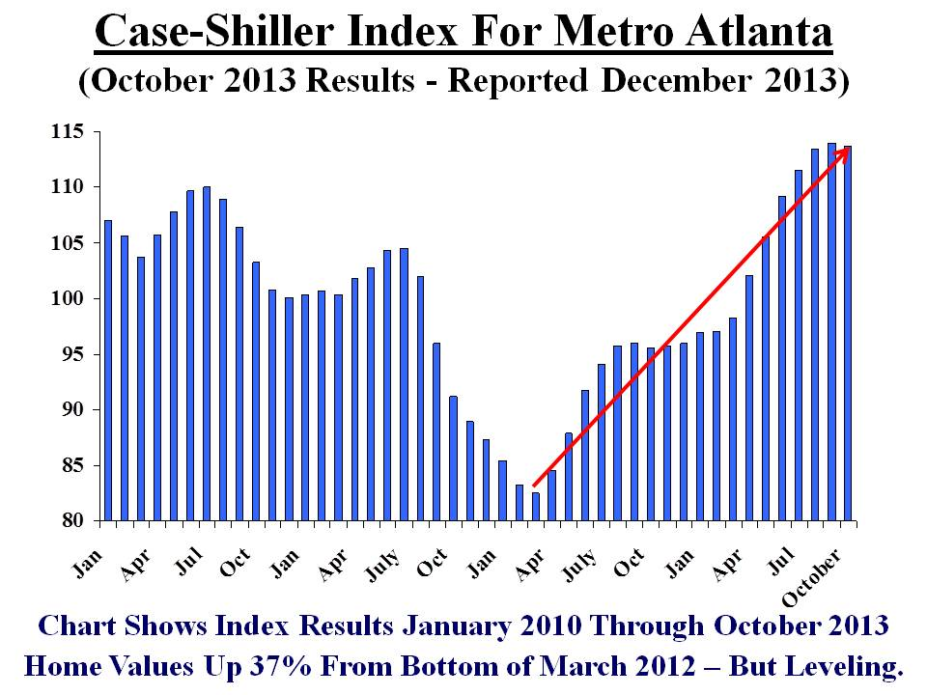

 If you look back further at home values (see chart below), you can see that we had a bubble in homes values. As with many cyclical markets, we have over-corrected with values that are below the normal trend line. Over time, we expect this pattern to normalize and values will return to this predictable track. That still makes now a great time to buy or invest in real estate for Metro Atlanta – BUT don’t wait too long!

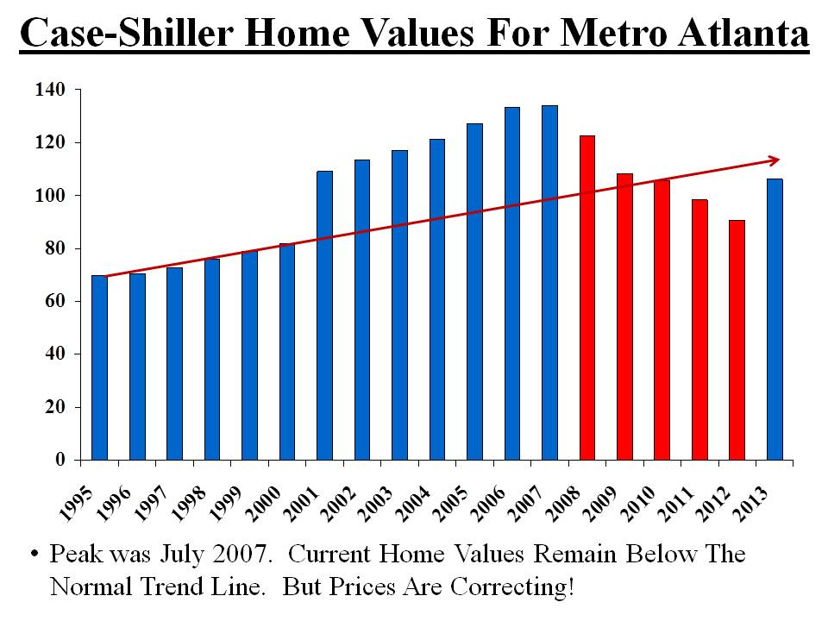

 This chart shows the “months supply” based upon price ranges. As you can see, the supply is very low in the lower price ranges. Investors have been very active in the price range but that slowed considerably. As you get to the luxury market, there is more supply available based on the slower rate of closed sales. Contact your local PGR agent to see the latest trends in your specific area.

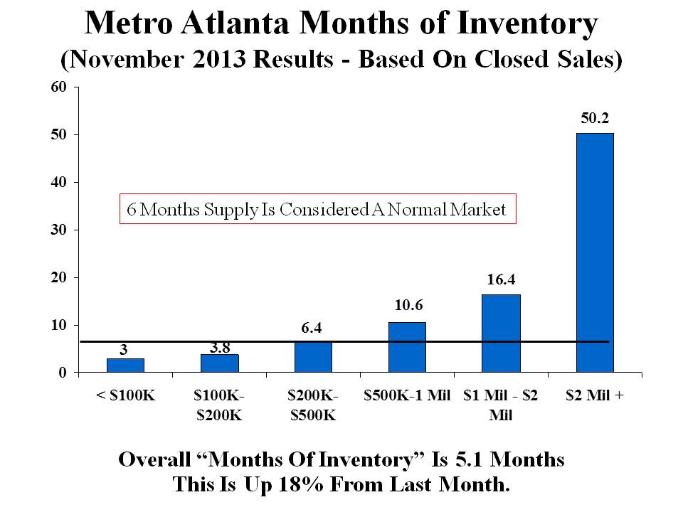

If you look at the average annual Case-Shiller index for each year, here is how homes purchased in recent years would compare to the current index:

Homes Bought in 2000 – Gain 10.16%  
Homes Bought in 2001 – Gain of 4.32%  
Homes Bought in 2002 – Gain of .45%  
Homes Bought in 2003 – Loss of 2.72%  
Homes Bought in 2004 – Loss of 6.03%  
Homes Bought in 2005 – Loss of 10.54%  
Homes Bought in 2006 – Loss of 14.62%  
Homes Bought in 2007 – Loss of 15.17%  
Homes Bought in 2008 – Loss of 7.28%  
Homes Bought in 2009 – Gain of 4.91%  
Homes Bought in 2010 – Gain of 7.52%  
Homes Bought in 2011 – Gain of 15.61%  
Homes Bought in 2012 – Gain of 25.36%

Yes, we are slowly climbing our way out of this unprecedented housing crisis – but we are not quite there yet. So where will home values go from here? The key factors that will impact our home values include the following:

**Demand from Buyers:** The long-term trend for buyer demand is strong as buyers take advantage while prices remain below replacement costs and mortgage financing is historically low. We continue to see significant pent-up demand for new household formation from first time buyers and a very active baby boomer market.  But the large investors have recently slowed their buying patterns for properties under $100,000. The last few months have seen a significant slowdown that is mostly seasonal.  We will be watching the buyer demand trends closely to determine of we have any changes in the leading indicators.

**Mortgage Rates/ Credit Availability:** Average mortgage rates in the past 50 years were 8%. Rates remain historically low but the long-term trend is higher. Freddie Mac and the Mortgage Bankers Association predict mortgage rates to rise to over 5% in 2014. In 3-5 years, we expect to see rates in the 6-8% range again.

**Supply/ Inventory Levels:** The inventory has been rising over the past few months as we move toward a more normal level of supply.  New homes will become a more significant part of the overall inventory by the spring.  Values have been on the rise but are showing signs of stability.  We expect more “sideline sellers” get back into the market for the spring. The “for sale” inventory this spring should be historically normal once again.

**Competition from Short Sales/ Foreclosures:** In 2010, RealValuator reports that short sales and foreclosures were over 60% of the transactions sold but have dropped to under 20% in 2013. Resales and new homes are significantly outpacing short sales and bank-owned properties.

**New Homes Make A Comeback:** New Home starts are rising and will slowly but surely become a major factor for Metro Atlanta real estate. In 3-5 years, we expect New Homes to return to 40%-45% of the inventory and closed sales. For resale owners, your competition will shift from foreclosures & short sales to new homes.

It is clear that the housing market for the Greater Metro Atlanta area is improving. Right now, we still have low prices and incredible mortgage rates. But the trends for mortgage rates are upward and home prices are increasing. Many buyers and sellers need to act quickly before their buying power in impacted significantly. In 5 or 10 years, many will look back and regret not buying their dream home when they had the chance! The cost of waiting could be quite significant. Check back for our next posts with the latest facts and insight that can make you money!

Prudential Georgia Realty has changed our name to Berkshire Hathaway HomeServices Georgia Properties.  Berkshire Hathaway is the 8th largest public company and was ranked the No.1 most respected company in Barron’s ranking of the top 100 companies. Berkshire Hathaway has the resources to bring a new level of quality and innovation to real estate.  Look for more exciting announcements coming soon!  For more information, visit [BHHSGeorgia.com](http://www.bhhsgeorgia.com/).