**Berkshire Hathaway HomeServices  
Georgia Properties   
Real Estate Advisor - October 2014**

We are providing this monthly real estate advisor to keep you informed about the latest trends and issues in the real estate market. Remember that real estate is local and every market is different. Contact us to find out exactly what is happening in your local area. If you know someone else who might be interested in receiving this report or who may benefit from our expertise, please let us know. **Better information helps our clients make better real estate decisions!**



* Closings for Metro Atlanta in August were down 16.9% compared to last month and down 2.5% compared to the previous year. This reflects the normal seasonal slowing for the fall.

[Click here for a detailed report.](http://www.atlrealestatescoop.com/wp-content/uploads/2014/10/Metro-Atlanta-Market-Trends-October-2014.pdf)

* The Metro Atlanta market is 50 units ahead of 2013 closings. If you exclude the heavy volumes of investors buying properties under $100,000 last year, the market above $100,000 is actually up 3084 units compared to 2013. The largest segment is $200k - $500k.
* The average sales price was $253,000 in September versus $256,000 in August. The average closed sale price for the full year was $250,000 which was up 42% from the bottom of 2011.
* Listed inventory was down .3% from last month and up 18.2% compared to last year. Inventory is up 50% from the recent bottom of February 2013. But the limited availability of highly desirable properties in select markets is still driving multiple offers and very quick sales. Remember, real estate is local and markets are different.
* Months of supply is 5.2 months versus 4.4 last month. Six months is considered normal.
* New Homes are making a comeback. The problem is that many builders cannot build them fast enough! At the peak of 2006, we were building over 60,000 new homes per year. Today, we are on pace to build around 18,000 new homes in 2014 and we expect to get to the 20,000 unit run rate by 2015. [Click here to view new home communities](http://newhomesservicesga.com/).

**Introducing Local Home Value Estimates**

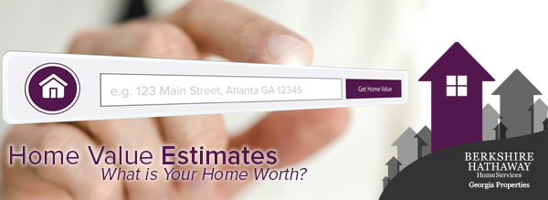

Berkshire Hathaway HomeServices Georgia Properties is introducing a new feature that allows consumers to enter an address to **“click and see” local home value estimates**. The estimates are free and do not require registration. The company is also introducing a new market trends report called **Market Watch (based on MLS data)** and a new **Interactive AVM (Automated Valuation Model)** report which is the same report used by lenders to estimate home values for mortgages.

"It is clear that consumers want to see home value estimates and we are pleased to be the first brokerage in Metro Atlanta to provide these innovative new solutions," said Dan Forsman, president & CEO of Berkshire Hathaway HomeServices Georgia Properties.  "Real estate is local. We have the advantage of proprietary MLS data, exclusive analytics tools and unique insight from our 1200 local experts. These powerful new tools will bring significant advantages that benefit our clients and our agents. And we are just getting started! Look for more exciting announcements very soon."

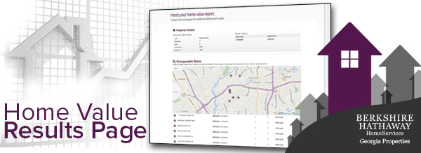

Home values estimates have become popular on national real estate websites like Zillow.com, Trulia.com and Realtor.com. The accuracy of these estimates is very mixed as the data is primarily based on tax records. The home value estimates provided by Berkshire Hathaway HomeServices Georgia Properties are powered by Collateral Analytics which has been rated as one of the most accurate sources by the lending industry. The report shows a value estimate, value range plus other data from tax records such as last sale price and date, comparable properties and local market trends.

**View Market Trends Including The Latest MLS Data**

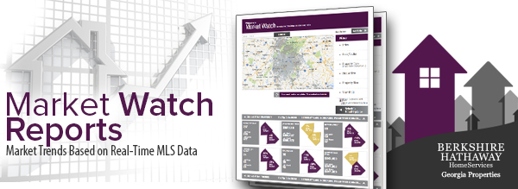

The Market Watch report includes local MLS data for a more accurate perspective of local market trends. If a property was sold yesterday, it would be reflected in this report as opposed to reports based on tax records which may take weeks or months to update. To view a Market Watch report, consumers can register for a free My Home Finder account. Only member brokerages and their registered clients can get access to local MLS data.

**Get Report Used By Lenders To Qualify Mortgages**

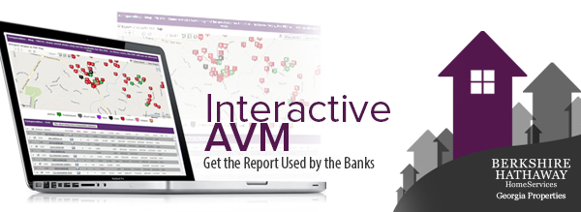

The new Interactive AVM (Automated Valuation Model) report is **the same report used by lenders to estimate home values for mortgage loans.** The I-AVM allows the agent to adjust comps and other factors for a more accurate value estimate. This powerful tool can combine MLS data, tax records and the unique insight from the local agent. The I-AVM is only available from your local Berkshire Hathaway HomeServices Georgia Properties agent.

Just visit our website or contact us to learn how to take advantage of these new innovations that provide better information about real estate. Better information leads to better decisions!

**If you or someone you know are considering moving, contact us to learn about our Advanced Property Marketing System – the most effective approach to selling your home for the highest value.**