


The Agent Business System will help you assess your past results and design a winning strategy & plan for 2016. Then you can implement your plan, measure the results and optimize each quarter. For agents who want a more comprehensive strategy & plan, we also provide the Advanced Agent Business System.

STEP ONE – ASSESS YOUR PERFORMANCE:

Results from Last Year

1. Total Closed Dollar Volume $_______________

2. Total Units Closed #_______________
(Sale of own listing = 2 units)

3. Total Earnings $_______________

4. Average Sale Price (#1 divided by #2) $_______________

5. Average Earnings Per Unit (#3 divided by #2) $_______________

** Results for first year agents can be annualized by dividing the number of active months and multiplying by 12. Example: $8500 earnings divided by 4 months = $2125 multiplied by 12 = $25,500 annually

Sources of Closed Transactions and Income

(Insert the number of transactions, dollar volume and GCI amounts in each category)
 | Buyers | Sellers | Investors | Renters/  Prop. Mgmt | Referrals | Team  Builder
Number
Transactions
$ Volume
GCI

Lead Generation Sources

(Insert the number for the sources of your closed transactions.)

 | Buyers | Sellers | Investors | Renters/  Prop. Mgmt | Referrals | Team  Builder
Past
Clients
Personal Network
Geographic Farming
Online Marketing
Social Networking
Business Networks
Expired Listings
FSBO
MEGA Open House
Company Lead
SURGE

2016 Goals and Objectives:

Business Goals and Personal Goals

2016 Coaching, Training or Agent Services
Should you sign up for Professional Coaching? Do you need to improve your Advanced Property Marketing System skills or customize your listing presentation? Do you understand how to use our tools for market trends and property research? Do you know how our alliance partners can help you be more successful? Do you know how to leverage our online marketing solutions? Do you know how to leverage our mobile solutions? Is your prospect database set up and segmented? Do you need to get Agent Marketing Services to do some things for you – so you can focus on selling? Should you get a new designation? Focus on the things that make you more valuable to your clients!
Planned Coaching, Training or Agent Marketing Services for 2015

I will make the commitment to participate in Professional Coaching! Initials: _________

STEP TWO – DESIGN YOUR PLAN:

Projections for New Year

1. Desired Personal Earnings $____________________

2. Projected Total Dollar Volume $____________________

3. Projected GCI $____________________

4. Projected Average Sale Price $____________________

5. Number of Transactions Required #____________________

- Additional Income (Referrals/ TeamBuilder) $____________________

Note: Is your plan realistic? Do you have listings or pendings that will carry over to 2016? Is your market big enough to support your desired earnings? Does your current strategy and plan support your desired results? If not, do not worry. We can help!

Business Generating Activities I Will Implement To Achieve My Desired Results:

Examples: enhance my prospect database, participate in 2016 Professional Coaching, Home Partners of America, host a client party, referrals from volunteer projects, farming, conduct open houses, work FSBOs, enhance online marketing, get started on Facebook, present market trends at a HOA meeting, target expired listings, invite co-op agents to events, create custom market reports or newsletter, etc.

Major Activities To Generate Buyers
1.
2.
3.
4.
5.

Major Activities To Generate Listings
1.
2.
3.
4.
5.

Major Activities To Generate Investors
1.
2.
3.

Major Activities To Generate Renters/ Property Management
1.
2.
3.

Major Activities To Generate Referrals/ TeamBuilder
1.
2.
3.

What are your primary concerns as you implement your business plan for the 2016? (Examples might include personal challenges or areas you need to improve. This may also include missed opportunities and competitive challenges in the marketplace.)

____________________________________________________________________________________________________________________________________________________________________________________________________________________________________________________________________________________________________________________________________________________________________

How can the broker, office staff, our corporate teams and our alliance partners assist you in achieving the results you desire in the upcoming year?

____________________________________________________________________________________________________________________________________________________________________________________________________________________________________________________________________________________________________________________________________________________________________

STEP THREE- IMPLEMENT YOUR PLAN:

These are the key things that need to happen to implement my 2016 plan.

_____________________________________________________________________________________________________________________________________________________________________________________________________________________________________________________________________________________________________________________________________________________________________________________________________________________________________________________________

STEP FOUR – MEASURE YOUR PERFORMANCE:

These are the key areas I plan to measure for 2016 that will have an impact on my business performance.

Area of Performance | Measurement

STEP FIVE – OPTIMIZE YOUR PLAN:

These are the dates that I plan to review my performance and optimize my business plan to achieve my goals in 2016. I have them scheduled on my calendar.

Designated Review | Planned Date of Review
End of 1st Quarter Review
End of 2nd Quarter Review
End of 3rd Quarter Review
End of 4th Quarter Review

I am committed to the activities necessary to achieve my desired results in 2016!

Sales Professional Name: __________________________________________________

Signature: _________________________________________ Date: ______________

Broker/ Coach: _____________________________________ Date: ______________

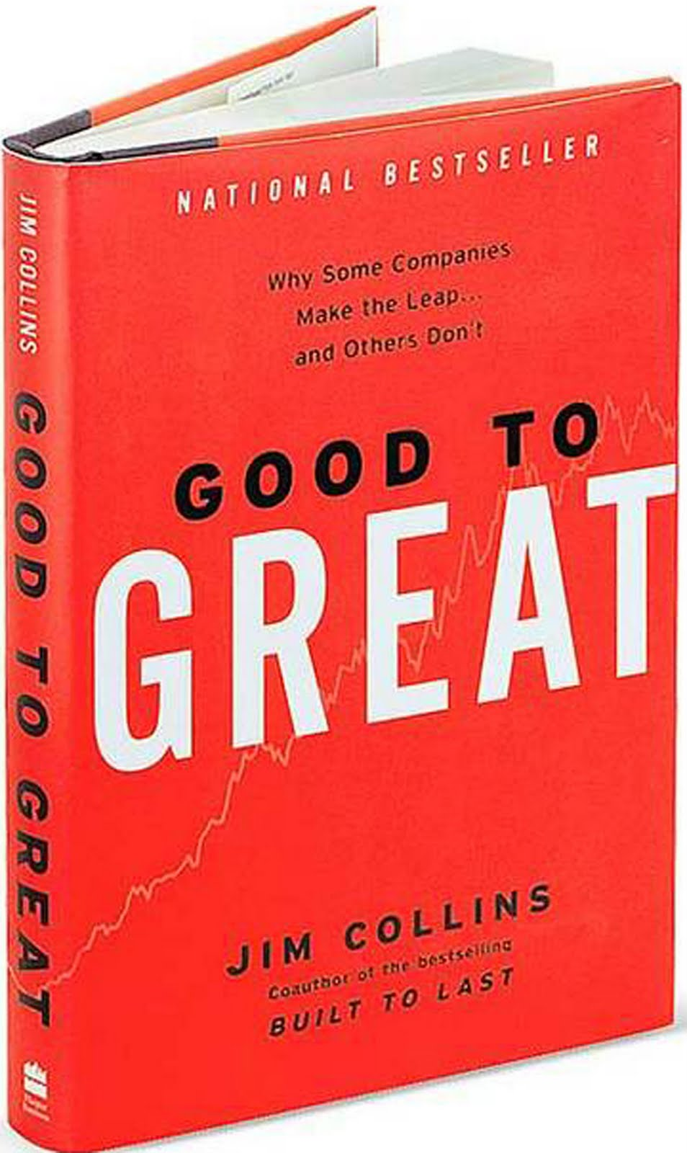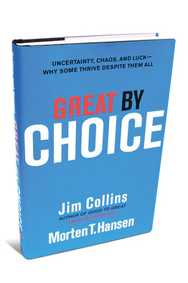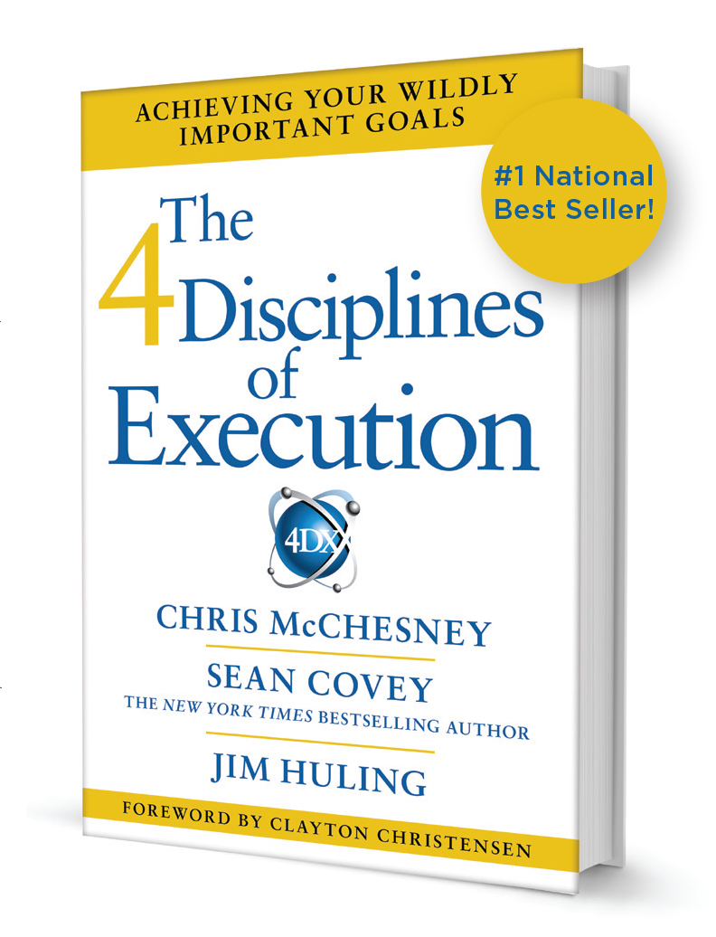

2016 Can Be The Best Year Of Your Career...
Make The Choice To Work Smarter!

