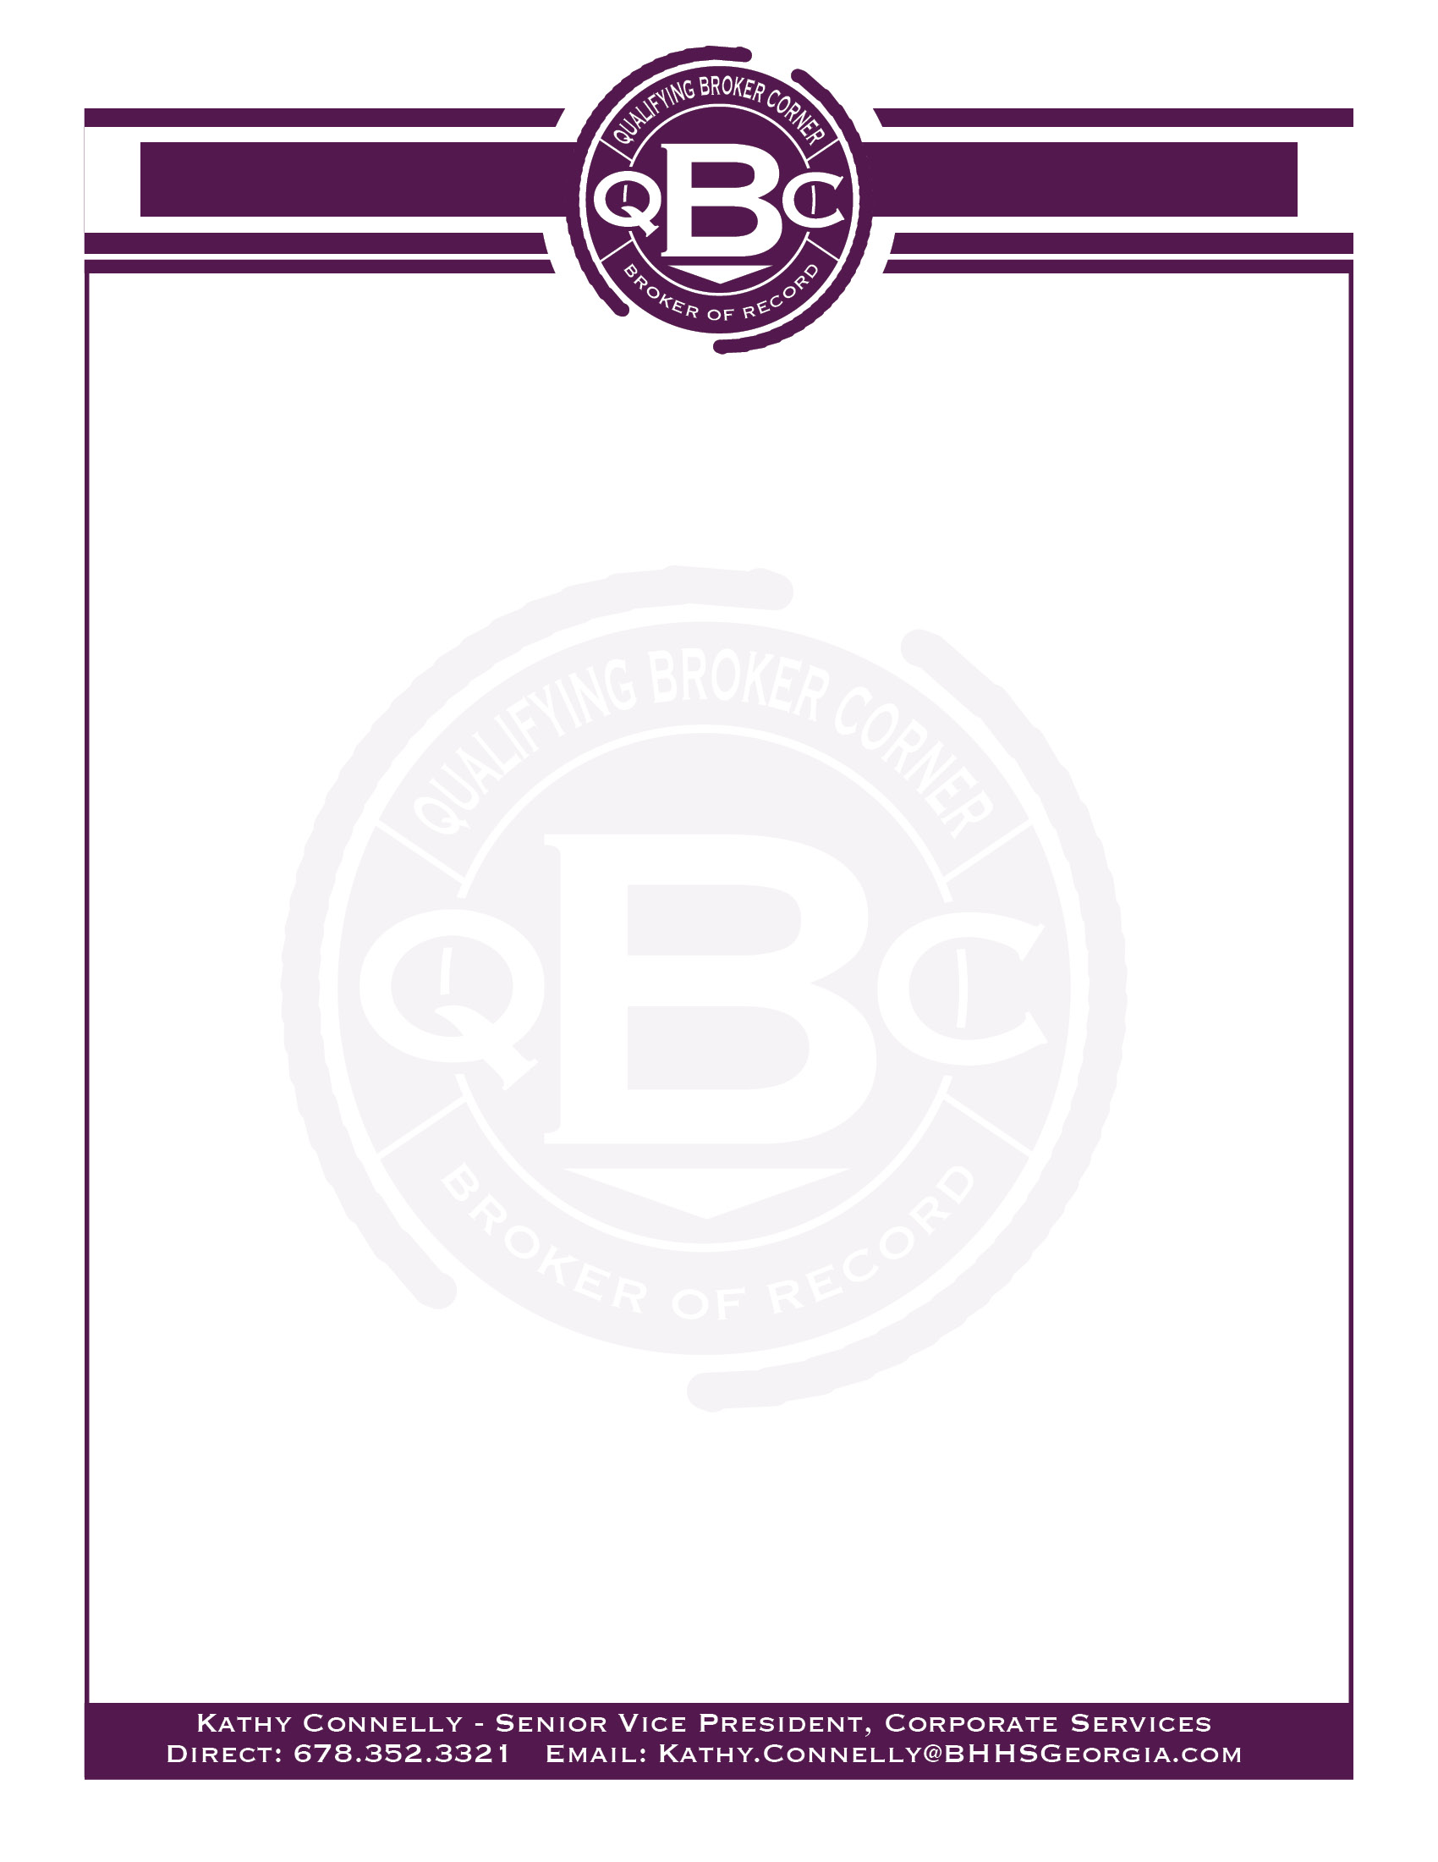

**Social Media Marketing**

**Rule 520-1-.09**

**Advertising on the Internet**

Any advertising on the Internet by a licensee of real estate for sale, rent, lease, or exchange shall disclose the name and telephone number of the licensee’s firm on every viewable web page of the website…with some exceptions:

* Some forms of internet advertising have very limited space or a limited number of characters that can be displayed. When it is not possible to include the firm name and telephone number on every page, **the Rule offers a method to be in compliance by including a direct link (needing only one-click)** to a web page (i.e. listing detail page) that can comply with this Rule and provide the needed information.
* Examples of situations that **require a direct link** to a display that contains this information include:
  + Electronic messages of limited information or characters (such as texts, tweet, and instant messaging, etc.)
  + Advertising on the internet website not owned or controlled by a licensee or firm and that website’s terms of use limit the licensee’s ability to comply with this paragraph, such as not allowing the inclusion of the listing firm name, firm phone number and in the correct font size, etc.

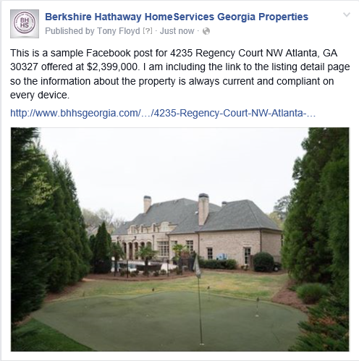**Here is an example:**

In this example, we are showing a post to Facebook. The Facebook image and text cannot be updated to reflect status changes, price changes or all the appropriate contact information and disclaimers. By including the link to the Listing Detail Page, you can show the latest updates so your property is always compliant – including that the property was sold!



**(Page 2)**

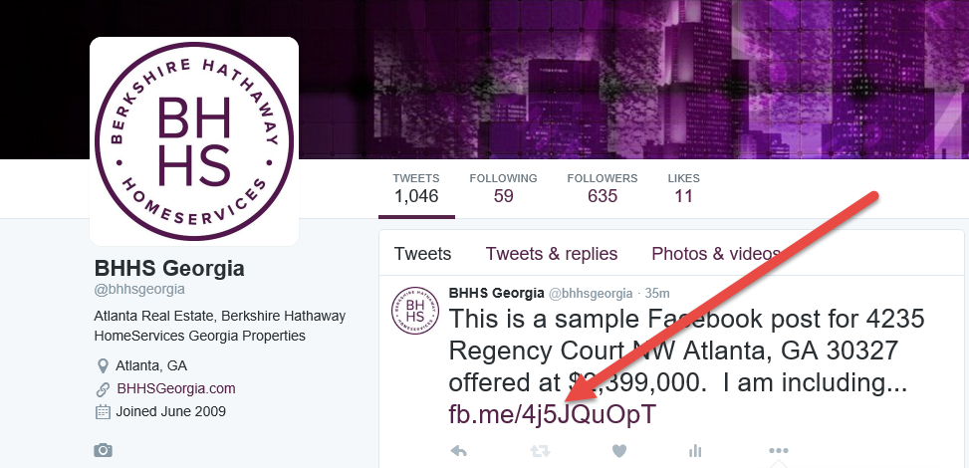Here is another example from Twitter. Again, the link to the listing detail page will help keep you compliant.

**The long standing rule that the licensee’s name and phone number cannot be any larger or more prevalent than the firm name and main phone number still holds true.**

* + The name of the firm advertising the real estate for sale, rent or exchange and the firm’s telephone number must appear in equal or greater size, prominence, and frequency than the name or names of any affiliated licensees or groups of licensees; and the phone number must be a number at which the public can reach a broker or a manager of the firm.

Source: Georgia Real Estate Commission  March 2016