**Instructions to Clear Cookies on Safari and Vote Again**

**(iPhone Version)**

Step 1: Copy the URL for Voting

<http://www.bizjournals.com/atlanta/pulse/survey/2016-most-admired-ceos/19941502?ana=e_atl_rdup&s=newsletter&ed=2016-06-10&u=ijOE1eP%2BZP%2BYviQXJS7EQK3BWo&t=1465559268&j=73920022>

You can also search your email for “AnnounceMyMove” and select the AMN message for Vote for Dan. Once you clear your cookies, you can click to re-open the link to vote.

Step 2: Select Your Settings Controls

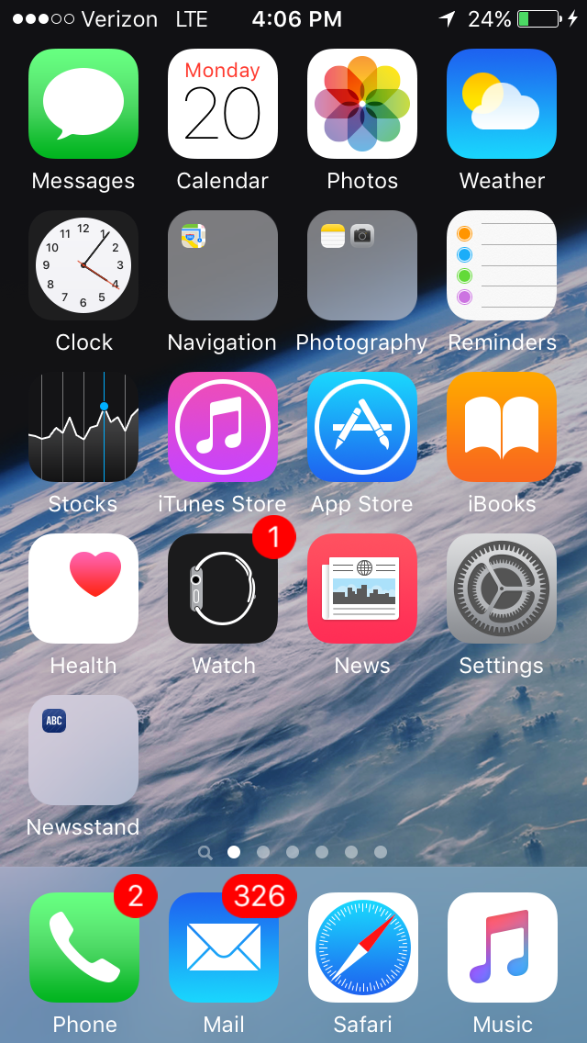

Step 3: Select Safari

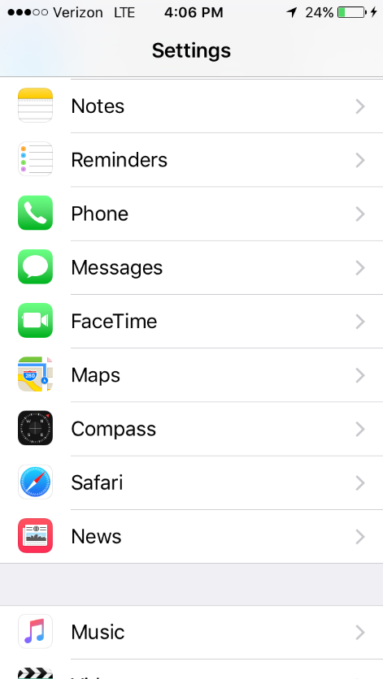

Step 4: Select Clear History and Website Data

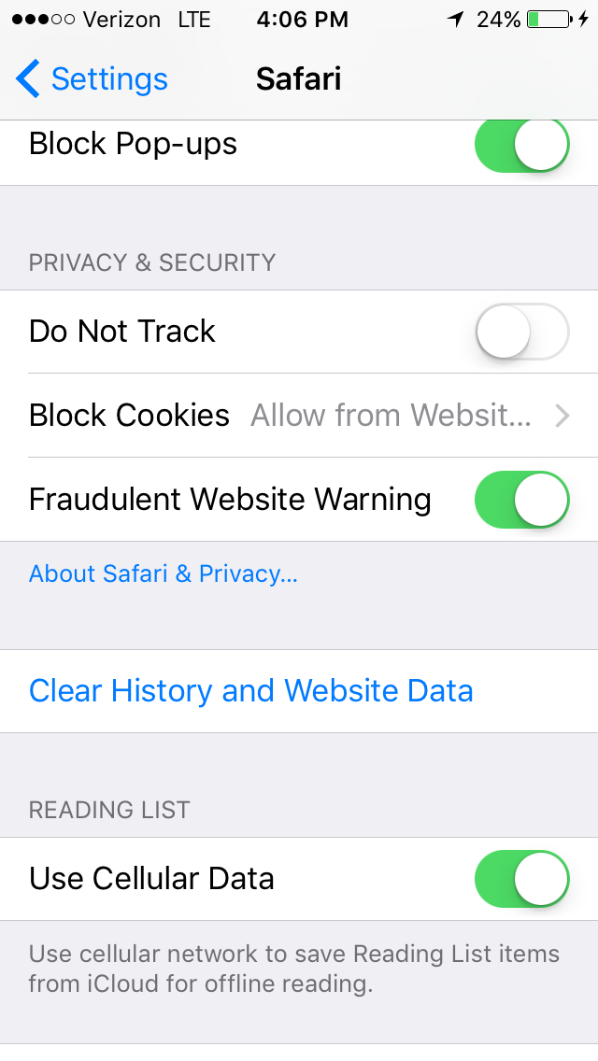

Step 5: Paste the Link to Your Safari Browser or Click the AMN Link to Open ABC Page. Then Vote Again!