**Dan Forsman, President/CEO of Berkshire Hathaway HomeServices Georgia Properties Announces Merger with KORA Real Estate Group**

**and Founder Karen Rodriguez to Form CITY HAUS**

ATLANTA/MIDTOWN/BUCKHEAD . . . . In a joint statement by Dan Forsman, President and CEO of Berkshire Hathaway HomeServices Georgia Properties, and Karen Rodriguez, founder and CEO of KORA Real Estate Group, the two residential real estate leaders announced that they have joined forces to launch CITY HAUS, a new Berkshire Hathaway HomeServices Georgia Properties division focused on Buckhead, Midtown, Intown and Downtown condominium development. Ms. Rodriguez has been appointed as Vice President of CITY HAUS, and will work with Lori Lane, Senior Vice President of the New Homes Division and the firm’s Luxury Collection marketing, to create, launch and grow this division to meet the needs of Atlanta’s most prominent condominium developers. CITY HAUS will be associated with the Berkshire Hathaway HomeServices Georgia Properties Midtown office, headed by Kerman Haynes, Vice President and Managing Broker.

Dan Forsman, elected “CEO of the Year” in Residential Real Estate for the 2nd consecutive year by *Atlanta Business Chronicle* readers, confirmed, “The merger with KORA Real Estate Group enables us to expand our new condo division. With their unsurpassed experience and expertise in the luxury condominium market, Karen Rodriguez and the KORA Real Estate Group in our new CITY HAUS division will have the boutique service and attention combined with the power of our global brand. This is an exciting step forward for Berkshire Hathaway HomeServices Georgia Properties and our dominance in luxury market share growth for properties closed over $500,000 and above $1 million.”

Karen Rodriguez, dubbed by many real estate leaders and journalists as the “Condo Queen,” has earned a sterling reputation for her expertise in the luxury condo new development niche. KORA’s current portfolio includes $60 million in listings at the Residences at Mandarin Oriental and several other undisclosed yet major Midtown projects. Ms. Rodriguez’s impressive record of sales and marketing of the city’s most prestigious projects includes the $100 million sellout of the Ritz-Carlton Residences during the housing crisis aftermath, and the revival of sales at the Mandarin Oriental Residences. The KORA team secured two of the highest residential sales in 2015, one for a $3,200,000 shell space and another for $3,888,000.

Ms. Rodriguez explained that, “Our team of dedicated new development specialists partner with premier luxury high-rise developers to bring marquee projects to market in the Buckhead, midtown and downtown areas of Atlanta. The KORA team works from inception, pre-development, or at any point in the development process to formulate the brand, marketing, design and sales infrastructure necessary to create value and sell Atlanta’s most prominent properties.” She added that “With the finest resources and market data available, we’re thrilled to be able to offer our clients the full power of the Berkshire Hathaway HomeServices Georgia Properties brand, which leads the Metro market in closed transactions, listing sales and buyer sales for the first half of 2016 as it has for the past seven years.  The strength of their global network and recognition of as one of the world’s most respected companies are incredible assets and important to the services we provide our buyers and sellers.”

Having successfully managed and expanded the New Homes Division since 2006, winning numerous OBIES and awards and controlling 14% of the new construction market share over the last several years, Lori Lane is an established authority in new home development. The New Homes Services division is the largest provider of new homes sales and marketing services for any brokerage.   Her creativity has driven the creation of the Black and White Elegance marketing campaign for Berkshire Hathaway HomeServices Georgia Properties and has resulted in the success of the firm’s Luxury Collection. Dan Forsman called the “team of Lori Lane and Karen Rodriguez truly a masterful duo of high-powered, energetic and knowledgeable real estate leaders.”

For more information and to discuss condominium and development needs, please contact [lori.lane@bhhsga.com](mailto:lori.lane@bhhsga.com) or [karen.rodriguez@bhhsga.com](mailto:karen.rodriguez@bhhsga.com) or [kerman.haynes@bhhsga.com](mailto:kerman.haynes@bhhsga.com).

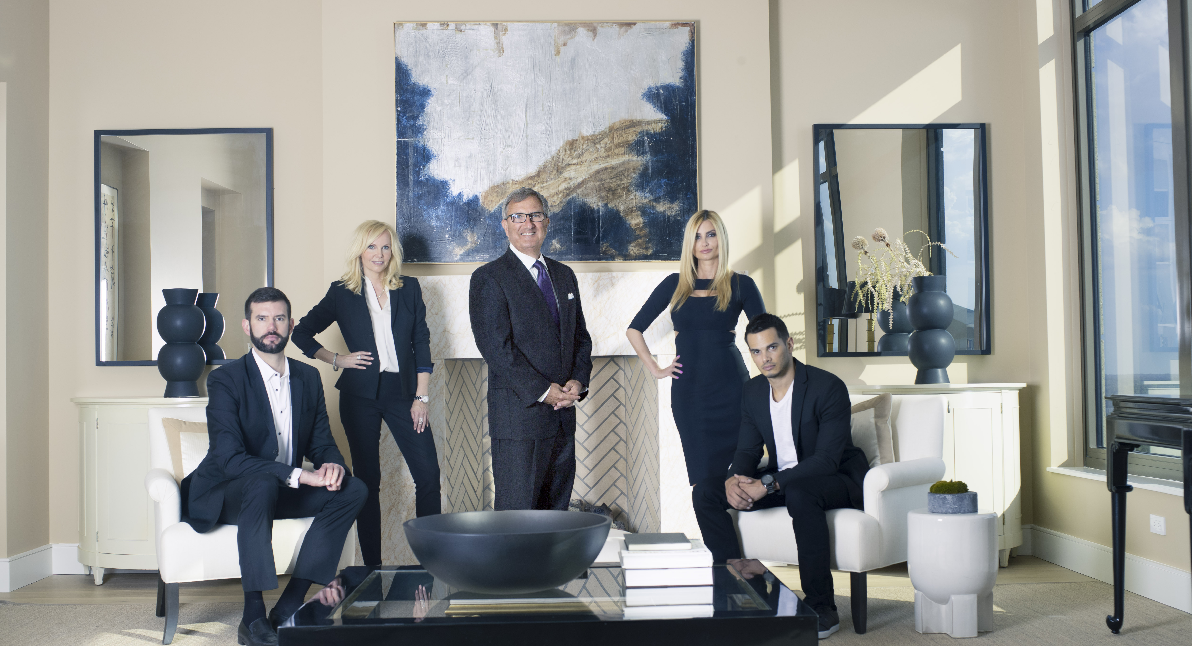

##### Photography by Wes Graham