


Table of Contents
3 What's Going On in the Housing Market Right Now?
- Top Reasons To Own Your Home

- The Difference Between Renting and Buying a Home
- The Return of Normal Seasonality for Home Price Appreciation
- How Homeowner Net Worth Grows with Time
- What Experts Project for Home Prices over the Next 5 Years
- The Impact of Changing Mortgage Rates

- Ways To Overcome Affordability Challenges in Today's Housing Market
- Beginning with Pre-Approval

- Things To Avoid After Applying for a Mortgage
- Advice for Making Your Strongest Offer on a Home
21 Why You Need a True Expert in Today's Housing Market

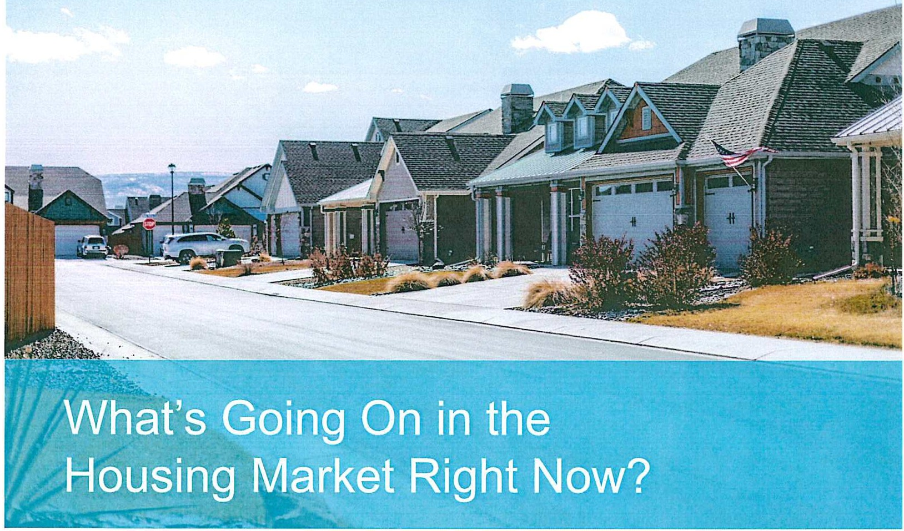

You might be wondering how the latest housing market updates will impact your winter home-buying plans. Here are the top three questions that might be on your mind.

What's Happening with Home Prices?
If you're keeping up with the news, you might be a bit confused about what's happening with home prices. Well, know this: despite what you may have heard, they're not going down. In fact, it's just the opposite. National data from several sources says home prices have been going up consistently since early 2023.
But it's important to know prices differ depending on where you live. Overall, the limited supply of homes for sale and ongoing buyer demand are going to keep upward pressure on prices. As Freddie Mac states:
"Overall, it appears the reduction in supply has outweighed the decrease in demand, thus house prices have started to increase ..."
So, with prices going up again, if you find a home that suits your needs, it's probably not the best idea to wait.

What's the Deal with Mortgage Rates?
Since October of 2022, rates have been between 6% and 8%. The rates we experienced a few years ago, like 3%, are now a thing of the past.
But beyond that, no one knows for sure where mortgage rates will go from here. Even the experts can't say with certainty what's going to happen next.
The best advice for your move is this: don't try to control what you can't control. This includes trying to time the market or guess what the future holds for mortgage rates. As CBS News states:
"If you're in the market for a new home, experts typically recommend focusing your search on the right home purchase - not the interest rate environment."

What Does Low Housing Inventory Mean for My Move?
Housing inventory is measured by the number of available homes on the market. It's also measured by months' supply, meaning the number of months it would take to sell all those available homes based on current demand. Bankrate says this about inventory:
"Traditional wisdom states that the real estate market needs 5 to 6 months of housing supply to be balanced, or not leaning toward either a buyer's market or seller's market."
Home sales data from the National Association of Realtors (NAR} shows inventory at a 3.6-month supply as of October. With inventory this low, it's important to consider all housing types as you look for affordable options. Working with a professional can help you in your search.

Bottom Line
Let's get in touch, so you have an expert to answer all your questions about the housing market. We'll discuss your goals and what's happening in our local area, so you'll have the information you need to make a smart and confident decision.

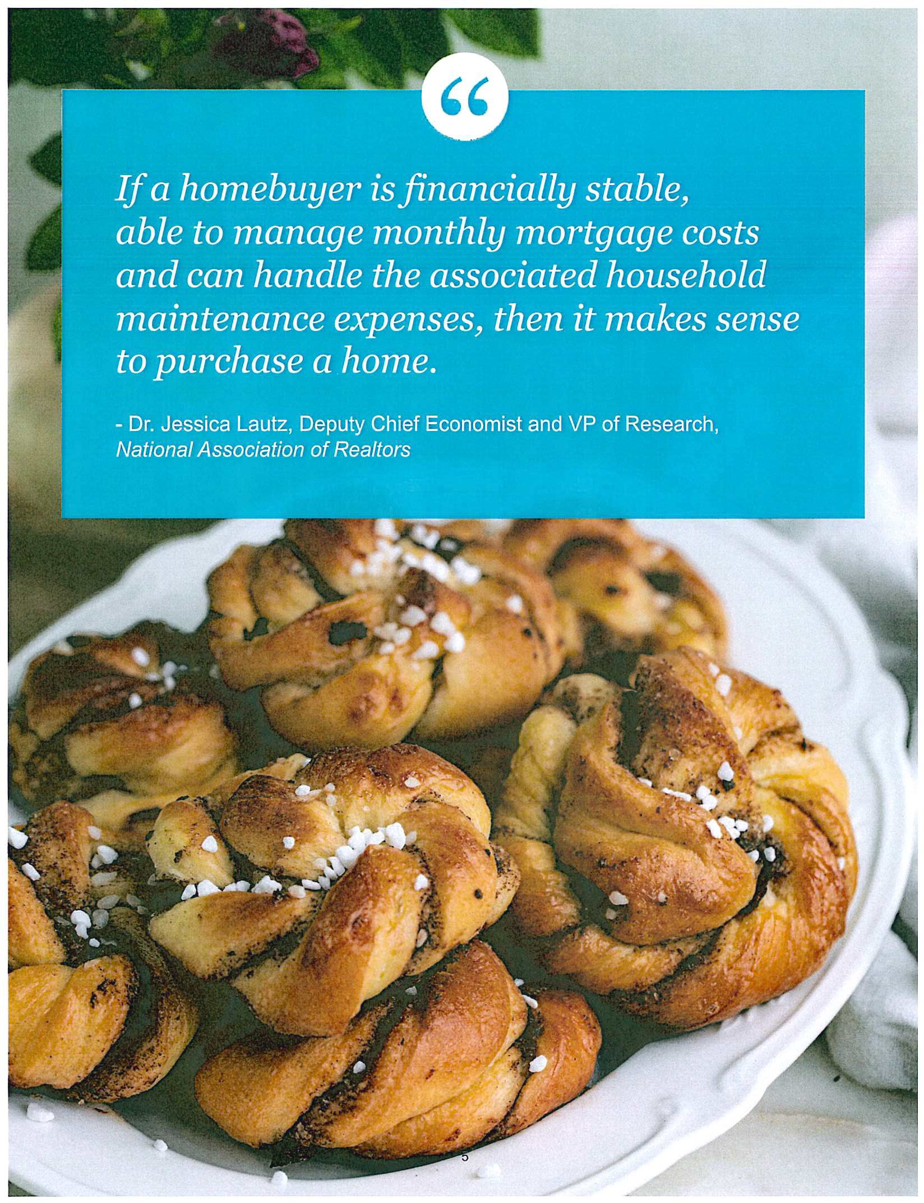





·- '

Feeling a sense of achievement and pride

Growing your assets and net worth

Tailoring your home to your unique style
Prioritizing the needs of those closest to you

Enjoying features that enhance your lifestyle

Being a part of a broader social group
Locking in your monthly housing payment with a fixed-rate mortgage

Having a space that's your own

If you're ready to buy a home, let's get the process started today.

Between Renting and Buying a Home
The Difference

When deciding between buying a home or renting, think about these three important factors.

Buying a Home Means Avoiding Rising Rents

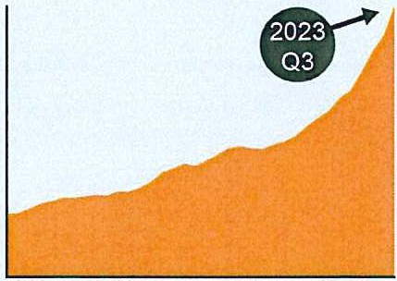
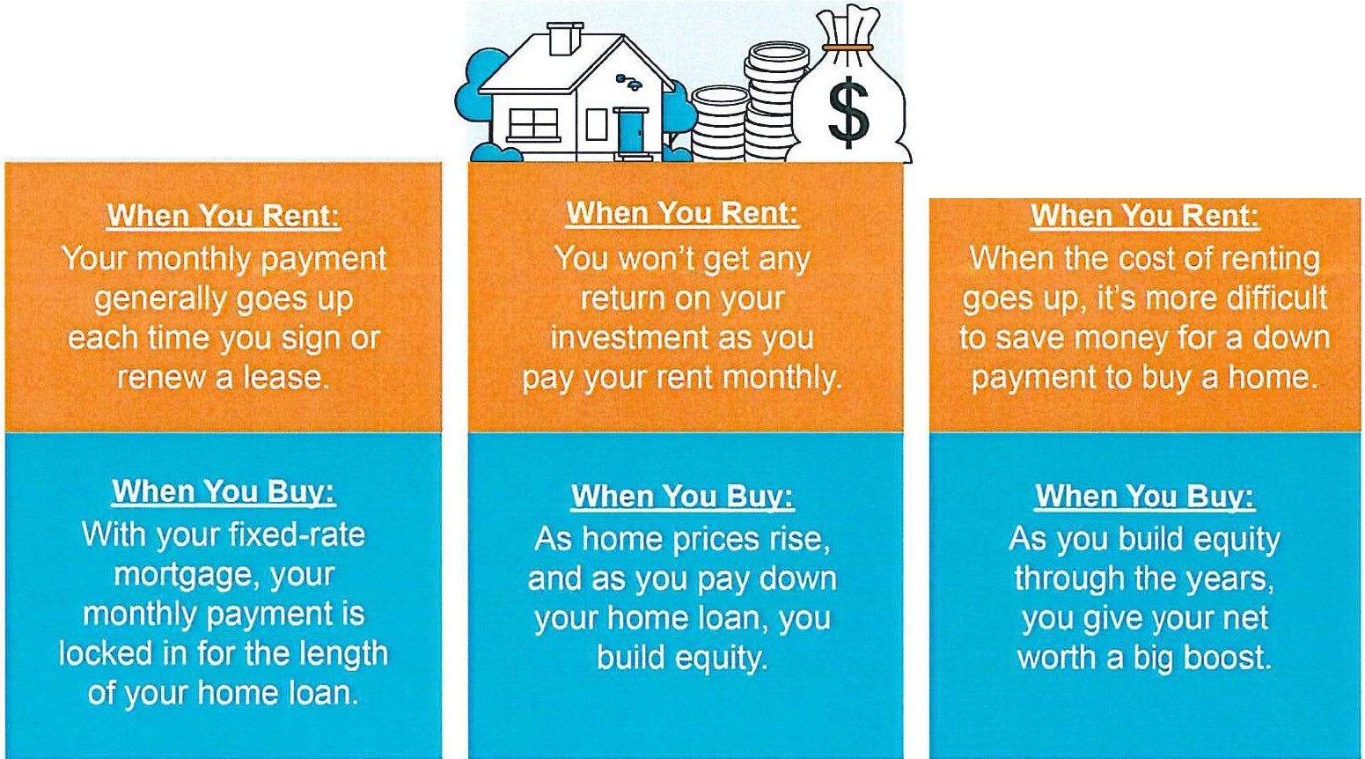
Median Asking Rent Since 1988

1988 1998 2008 2018

Homeowners Own a Tangible and Valuable Asset

... theaverage U.S. homeowner now has about
''
$290,000 in equity.
Corelogic

Owning Your Home Grows Your Wealth Over Time

A monthly mortgage payment is often considered a forced savings account that helps homeowners build a net worth about 40 times higher than that of a renter.
''
Lawrence Yun
Chief Economist, NAR
Jlld

The Return of Normal Seasonality for Home Price Appreciation

If you're thinking of buying a home, one of the biggest questions you have right now is probably: what's happening with home prices?
Despite what you may have heard in the news, nationally, home prices aren't falling. It's just that price growth is beginning to normalize. Here's the context you need to really understand that trend.
The housing market has predictable ebbs and flows that happen each year. It's called seasonality. Spring is the peak homebuying season when the market is most active. That activity is still strong in the summer but begins to wane as the cooler months approach. Home prices follow along with seasonality because prices appreciate most when something is in high demand.
That's why there's a reliable long-term home price trend. The graph below uses data from Case­ Shil/er to show typical monthly home price movement from 1973 through 2022 (not adjusted, so you can see the seasonality):

49-Year Average Monthly Price Movement
% Month-Over-Month Price Movement (1973-2022, Not Seasonally Adjusted)
0•86
0.88 --
0.79
- -
0.64 -r7 n_
0.64
-nrl8 I
-,_I LI I_I
r--r-
May
Jun
H ITTn- -
2
o.
,
Jan Feb Mar Apr
Jul Aug Sep Oct Nov
Dec
Source: Case-Shiller
As the data shows, at the beginning of the year, home prices grow, but not as much as they do in the spring and summer markets. That's because the market is less active in January and February since fewer people move in the cooler months. As the market transitions into the peak homebuying season in the spring, activity ramps up, and home prices go up a lot more in response. Then, as fall and winter approach, activity eases again. Price growth slows, but still typically appreciates.

After several unusual years, today's higher mortgage rates helped usher in the first signs of the return of seasonality. As Selma Hepp, Chief Economist at CoreLogic, explains:
"High mortgage rates have slowed additional price surges, with monthly increases returning to regular seasonal averages. In other words, home prices are still growing but are in line with historic seasonal expectations."

Why This Is So Important To Understand
In the coming months, you're going to see the media talk more about home prices. In their coverage, you'll likely see industry terms like these:
. Appreciation: when prices increase.
- Deceleration of appreciation: when prices continue to appreciate, but at a slower or more moderate pace.
Depreciation: when prices decrease.
Don't let the terminology confuse you or let any misleading headlines cause any unnecessary fear. The rapid pace of home price growth the market saw in recent years was unsustainable. It had to slow down at some point and that's what we're starting to see - deceleration of appreciation, not depreciation.
Remember, it's normal to see home price growth slow down as the year goes on. And that definitely doesn't mean home prices are falling. They're just rising at a more moderate pace.

Bottom Line
While the headlines are generating fear and confusion on what's happening with home prices, the truth is simple. Home price appreciation is returning to normal seasonality. If you have questions about what's happening with prices in our local
area, let's connect.

How Homeowner Net Worth Grows with Time
benefits of homeownership.

Home Equity Boosts Your Net Worth
If you're thinking about buying a home this year, be sure to
consider the long-termfi.nancial
Equity is the current value of your home minus what you still owe on your loan. It goes up when:
i••••
j •••
•

- You pay down your loan
i. •··
- Home price appreciation makes your home's value go up

Here's a look at how just the home price appreciation piece can increase your wealth over time.

Percent Change in Home Prices
Since Q1 1991, Q3 2023

Pacific
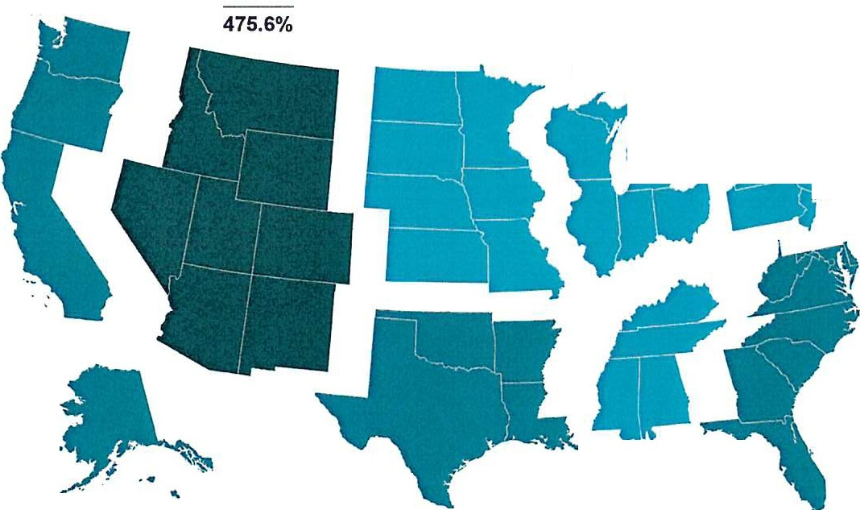

351.1%
% Change in House Prices
- >500%
Since 1991 Q1
- 400%-500%
■
- 300%-400%
- 200%-300%
- 0%-100%
100%-200%

Mountain

West North Central
284.6%

New England
East North Central 287.3% 231.1%

......

•
M-idd-le A-tla-ntic 1
260.3%41
.. -/

South Atlantic
338%

,.,.

.,. West South Central
- 312.4%

East South Central
279.2%

306.4°/o
National Average:

Source: FHFA



If you're thinking of buying a home, you want to know what experts predictfor home prices in the future and how that might affect your investment. Here's what the experts are projecting.

Experts Project Ongoing Appreciation
Pulsenomics polled over 100 economists, investment strategists, and housing market analysts in the latest quarterly Home Price Expectation Survey (HPES). The results show what the panelists project will happen with home prices over the next five years. Here are those expert forecasts saying home prices will go up every year through 2027 (see graph below):
Estimated Home Price Performance
December to December, as Forecasted inQ3 2023
4.18%
3.32°/c
3.24°/c)
3.79%
I
I I
2 17
- % I
I
II
11
I
2023
2024
2025
2026
2027
Source: HPES

If you're someone who was worried home prices would fall because of stories you've read online, here's the big takeaway. Even though home prices vary by local market, experts project prices will continue to rise across the country for years to come. And these numbers indicate the return to more normal home price appreciation.
And while the projected increase in 2024 isn't as large as 2023, it's important to recognize home price appreciation is cumulative. This is a good example of why owning a home is a choice that wins big over time.

What Does This Mean for You?
Once you buy a home, price appreciation raises your home's value, and that grows your household wealth. To see how a typical home's value could change in the next few years using the expert projections from the HPES, check out the graph below:
$71,363
Potential growth in household wealth over the next 5 years based solely on increased home equity if you purchased a $400K home in January 2023
$471,363
$452,451
:t,4;:5!:>' L
$422,248
$400,000
$413,280
Based on pn. ee apprec1•at1• on projected bY the HPES
2023
2024
2025
2026
2027
2028
Source: HPES

In this example, let's say you bought a $400,000 home at the beginning of 2023. If you factor in the forecast from the HPES, you could potentially accumulate more than $71,000 in household wealth over the next five years.
So, if you're thinking about whether buying a home is a good choice, remember how it can be a powerful way to grow your wealth in the long run.

Bottom Line
According to the experts, home prices are expected to grow over the next five years at a more normal pace. If you're ready to become a homeowner, know that buying today can set you up for long-term success as home values (and your own net worth) grow. Let's connect to start the homebuying process today.



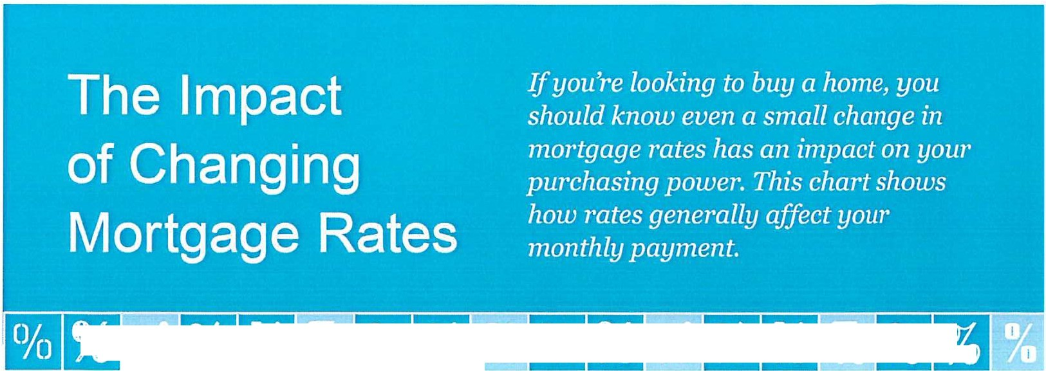
'II Vi>FJJWl 11MR
--
iFJJBtl4'1ii IMILi

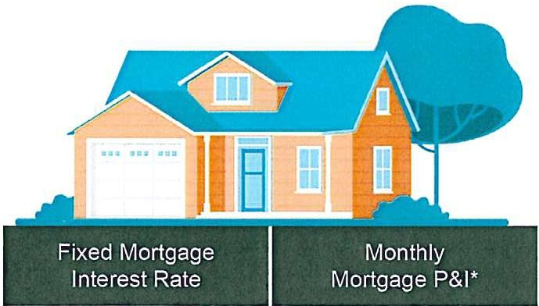
Home Loan Amount
Monthly Difference



$250,000
8.0% | $1,834.41
7.5% | $1,748.04 |  | $86.37
7.0% | $1,663.26 |  | $171.15
6.5% | $1,580.17 |  | $254.24
8.0% | $3,301.94
7.5% | $3,146.47 |  | $155.47
7.0% | $2,993.86 |  | $308.08
6.5% | $2,844.31 |  | $457.63



$450,000 I

-8.0%
$800,000 Ir -7.0%
11 $5,870.12

$5,593.72
I
$276.40
7.5% 11
 | 11 | $5,322.42 | $547.70
6.5% | II | $5,056.54 | $813.58

--

*Principal and Interest Payment.
Total monthly payment may vary based on Joan specifications such as property taxes, insurance, HOA dues, and other fees. Interest rates used here are for marketing purposes only. Consult your licensed Mortgage Advisor for current rates.
14 Sources: MortgageCalculator.net, Trading Economics




Expand Your Search Area
(8)

With so few homes on the market right now, widening the scope of your search to include nearby areas could help you find more options in your budget.

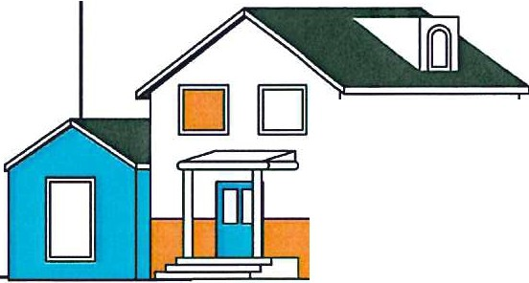

;Multi-Generational Living Can Hel
.:. .;.;,:½=r°-4=.

'fl(lj.
.
( · .
_. ::
Choosing multi-gen living allows people to purchase a home much larger than they could afford on their own by leveraging the combined income, credit and a down payment of those they will be occupying the home with.
Triangle Business Journal
□□

Search for Down Payment Assistance
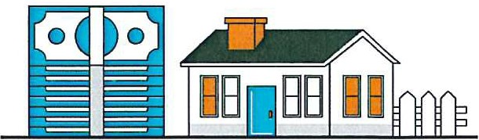
There are more than 2,000 down payment assistance programs in the United States. If you're interested in learning more, information is available through sites like Down Payment Resource.

Sources: The New York Times,
15 Down Payment Resource



If you're looking to buy a home this winter, the.first thing you'll want to do is get pre-approved for a mortgage. That way you'll know your numbers and can set yourself up for success from the start of your home search.

What Is Pre-•Approval?
Freddie Mac explains it like this:
' pre-approval is an indication from your lender that they are willing to lend you a certain amount of money to buy your future home....
Keep in mind that the loan amount in the pre-approval letter is the lender's maximum offer. Ultimately, you should only borrow an amount you are comfortable repaying."
Basically, pre-approval gives you critical information about the homebuying process that'll help you understand how much you may be able to borrow.

How Does It•Work?
As part of the homebuying process, a lender looks at your finances to determine what they'd be willing to loan you. From there, your lender will give you a pre-approval letter to help you know how much money you
can borrow.

Why does this help you, especially today? With higher mortgage rates and home prices impacting affordability for many buyers right now, a solid understanding of your numbers is even more important so you can truly wrap your head around your options.



Pre-Approval Helps Show Sellers You're a Serious Buyer
Let's face it, there are more buyers looking to buy than there are homes available for sale and that imbalance is creating some competition among homebuyers. That means you could see yourself in a multiple-offer scenario when you make an offer on a home. But getting pre-approved for a mortgage can help you stand out from other hopeful buyers.
As an article from Wall Street Journal
(WSJ) says:
"If you plan to use a mortgage for your home purchase, preapproval should be among the first steps in your search process. Not only can getting preapproved help you zero in on
the right price range, but it can give you a leg up on other buyers, too."
Pre-approval shows the seller you're a serious buyer that's already undergone a credit and financial check, making it more likely that the sale will move forward without unexpected delays or financial issues.

Bottom Line
Getting pre-approved is an important.first step when you're buying a home. The more prepared you are, the better chance you have of getting the home you want.
Connect with a trusted lender so you have the tools you need to purchase a home in today's market.

Consistency is the name of the game after applying for a mortgage. Be sure to discuss any changes in income, assets, or credit with your lender, so you don't jeopardize your application.
Things To Avoid After Applying for a Mortgage



7
........"........-...............

Don't change bank accounts.
Don't apply for new credit or close any credit accounts.


>))
•1234.:

-5579 9876·.5432


Don't deposit cash into your bank accounts before speaking with your bank or lender.

-

Don't co-sign other loans for anyone.


Don't make any large purchases.
-,




The best plan is to fully disclose and discuss your intentions with your lender before you do anything financial in nature.
'
. ,,


;.,.•
; ¥k·;-;.-
- -- -. .•
:_
J '1' .
. '"
-•... •
t
i. '
" ....
...
•
• • -= .,.,_ , . '•.-r"Af,' ll;- •.
• ....·•,"..,;,.. -:-:•-.·"1:f::-•. ·":'.;:..¥,.. -'. . - . ; .
,._ -.,,:t:;>,•\· . . .
't.
\ '> ' ••.
•
, :.,< ..,,.
,.;;(>'
· •.
- l' .
;,,.
, "«.<
,_J .
-::;·...:.::_...J't:,:·. -- B

The housing market is competitive in many places right now because there aren't many homes for sale. If you're planning to buy a home this winter, here are some tips to help you make a strong offer.

Lean on a Real Estate Professional
Rely on an agent who can support your goals and help you understand what's happening in today's housing market. Agents are experts in the local market and on the national trends too. They'll use both of those areas of expertise to make sure you have all the information you need to move with confidence.
Plus, they know what's worked for other buyers in your area and what sellers may be looking for in an offer. It may seem simple, but catering to what a seller needs can help your offer stand out. As an article from Forbes says:
"Getting to know a local realtor where you're hoping to buy can also potentially give you a crucial edge in a tight housing market."

Get Pre-Approved for a Home Loan
Having a clear budget in mind is especially important right now given current affordability challenges. The best way to get a clear picture of what you can borrow is to work with a lender so you can get pre-approved for a home loan.
That'll help you be more financially confident because you'll have a better understanding of your numbers, and it also shows sellers you're a serious buyer. And that can give you a competitive edge if you do get into a multiple offer scenario.


'· "' / I,
' ;

Make a Fair Offer
It's only natural to want the best deal you can get on a home. However, submitting an offer that's too low does have some risks. You don't want to make an offer that will be tossed out as soon as it's received just to see if it sticks. As Realtor.com explains:

"... an offer price that's significantly lower than the listing price, is often rejected by sellers who feel insulted ... if a seller is offended by a buyer or isn't taking the buyer seriously, there's not much you, or the real estate agent, can do."
The expertise your agent brings to this part of the process will help you stay competitive and find a price that's fair to you and the seller.

Trust Your Agent's Expertise Throughout Negotiations
Over the past few years, some buyers skipped home inspections or didn't ask for concessions from the seller in order to submit the winning bid on a home. An article from Bankrate explains this isn't happening as often today and that's good news:

"It's in the buyer's best interest to have a home inspected ... Inspections alert you to existing or potential problems with the home, giving you not just an early heads up but also a useful negotiating tactic."
Fortunately, today's market is different, and you may have more negotiating power than before. When putting together an offer, your trusted real estate advisor will help you think through what levers to pull and which ones you may not want to compromise on.

.
.: Bottom Line
liVhen you go to buy a home this winter, let's talk so you can have an expert on your
: team to help you make your top offer.



In today's fast-changing housing market, having a trusted real estate agent is more important than ever. It's essential to work with an agent who can guide you through every step of the process.

The reality is, not all agents operate the same way. To truly make a powerful and confident decision as you buy a home, you need a real estate expert who uses their knowledge of what's really happening with home prices, housing supply, industry projections, and more to give you the best possible advice. Someone who can provide clarity and trust like that is essential to your success. Jay Thompson, Real Estate Industry Consultant, explains:
"Housing market headlines are everywhere. Many are quite sensational, ending with exclamation points or predicting impending doom for the industry. Clickbait, the sensationalizing of headlines and content, has been an issue since the dawn of the internet, and housing news is not immune to it."
Unfortunately, when information in the media isn't clear, it can generate a lot of fear and uncertainty in the market. As Jason Lewris, Co-Founder and Chief Data Officer at Pare/, says:
"In the absence of trustworthy, up-to-date information, real estate decisions are increasingly being driven by fear, uncertainty, and doubt."



But it doesn't have to be that way. Buying a home is a big decision, and it should be one you feel confident making. You can lean on an expert to help you separate fact from fiction and get the answers
you need.

The right agent can assist you in figuring out what's going on at the national level and in your local area.

They can debunk headlines using data you can trust. Experts have in-depth knowledge of the industry and can provide context, so you know how current trends compare to the normal ebbs and flows in the housing market, historical data, and more.

Then, to make sure you have the full picture, an agent can tell you if your local area is following the national trend or if they're seeing something different in your market. Together, you can use all that information to make the best possible decision.

After all, making a move is a potentially life-changing milestone. It should be something you feel ready for and excited about. And that's where a trusted expert comes in.

Bottom Line
If you want sound advice and trusted information about the housing market, reach out.





Let's Chat.

I'm sure you have questions and thoughts about the real estate process.
I'd love to talk with you about what you've read here and help you on the path to buying your new home. My contact information is below, and I look forward to working with you.

.
®
.
BERKSHIRE HATHAWAY I Kathy ReidRealty
HomeSer\'lces
Kathy Reid
Broker/Owner
Berkshire Hathaway HomeServices Kathy Reid Realty Hudson, OH
kreid@bhhsreid.com
2163906633

WINTER 2024 EDITION ,..,:,..,
*
QP,011to,;i.11Y

